East Sussex Drug Harm Reduction Strategy | 20010/13

Reducing the harm caused by drug misuse to individuals and communities in East Sussex

East Sussex Drug and Alcohol Action Team

Version | 6-FINAL
Author | Jason Mahoney  Joint Commissioning Manager
Published | 26 July 2010
Review by | 31 March 2013

East Sussex Drug Harm Reduction Strategy 2010-2013
EXECUTIVE SUMMARY 4
01 ▪ INTRODUCTION 4
Scope 4
National policy and research 5
Local policy and research 6
Strategy implementation 6
Summary of recommendations 7
02 ▪ INFORMATION AND ANALYSIS 8
Impact of previous strategy 8
Needs assessment 9
Harm reduction self-audit 16
NICE PH18 audit 16
Estimating the prevalence of injecting drug use 17
Coverage of needle and syringe programmes 17
Drug related deaths – local Confidential Inquiries 19
Blood-borne viruses 22
HPA Unlinked Anonymous Prevalence Monitoring Programme 28
Risks associated with co-morbidity 28
Workforce training needs analysis 28
Tackling drug related litter 28
03 ▪ CURRRENT SERVICES AND INTERVENTIONS 28
‘Tier 1’ 28
‘Tier 2’ 28
‘Tier 3’ 28
‘Tier 4’ 28
04 ▪ Gap analysis 28
05 ▪ PLANNED ACTIONS TO REDUCE HARM 28
Summary of high-impact changes 28
Other lower priority recommendations for action: 28
Strategic Management 28
Bibliography 28
Appendix One – Audit results 28
Appendix Two – Additional actions being completed 28

Index of tables
Table 1: Number of IDU 11
Table 2: Gender of IDU 11
Table 3: Age of IDU 11
Table 4: Ethnicity of IDU 11
Table 5: Housing Need of IDU 11
Table 6: Employment Status of IDU 12
Table 7: Local Authority of IDU 12
Table 8: Parental Status of IDU 12
Table 9: Number of children living with client 12
Table 10: Referral Source 13
Table 11: Hep B intervention status 13
Table 12: Number of Hep B vaccinations 13
Table 13: Hep C intervention status 13
Table 14: Discharge Reason 14
Table 15: Duration of treatment 14
Table 16: Primary, Secondary and Tertiary drug of current IDU 14
Table 17: Primary, Secondary and Tertiary drug of previous IDU 15
Table 18: Needle and Syringe Programme coverage calculation 17
Table 19: Notes to NSP coverage calculation 17
Table 20: Needles and syringes distributed 2008/9 19
Table 21: Annual drug related deaths 20
Table 22: Callouts to overdose/poisonings by District 20
Table 23: Number of callouts to accidental overdoses 21
Table 24: Callouts to accidental overdoses by age 21
Table 25: Current locations of pharmacy NSP 28
Table 26: Evening and weekend NSP availability 28
Table 27: Areas where pharmacy NSP is an identified gap 28

Glossary of abbreviations
Abbreviations are explained in the text the first time they appear. Commonly used abbreviations are also included in the table below.

IDU | Injecting Drug User
DAAT | Drug and Alcohol Action Team
ESDW | NHS East Sussex Downs and Weald
H&R | NHS Hastings and Rother
HAV | Hepatitis A
HBV | Hepatitis B Virus
HCV | Hepatitis C Virus
HIV | Human Immunodeficiency Virus
HPA | Health Protection Agency
NICE | National Institute for Health and Clinical Excellence
NSP | Needle and Syringe Programme
NTA | National Treatment Agency
PDU | Problem Drug User (a person who uses opiates or crack cocaine)
PHO | Public Health Observatory

EXECUTIVE SUMMARY

- This strategy describes the East Sussex Drug and Alcohol Action Team’s (DAAT) priorities for reducing drug related harm. The strategy focuses on adults, and particularly on opiates and crack cocaine. It describes the DAAT’s action plans to reduce drug related death and blood borne virus transmission, jointly agreed with the local Health Protection Unit.

- The strategy describes a clear need to improve the ‘coverage’ of local needle and syringe programmes, the percentage of injections ‘covered’ by sterile needles and syringes. This has been identified as the most urgent priority within the strategy. Increasing coverage will significantly reduce the risk of sharing, and the transmission of blood borne viruses.

- The strategy has been developed through a collaborative process that has included the users and providers of services. The strategy considers local need and proposes recommendations for improvement. The recommendations have been prioritised by the DAAT’s harm reduction group, which will be responsible for ensuring the strategy is delivered between April 2010 and March 2013.

01 ▪ INTRODUCTION

- The East Sussex Drug and Alcohol Action Team (DAAT) is the local (East Sussex) multi-agency partnership that addresses drug and alcohol issues. The DAAT includes NHS Hastings and Rother, NHS East Sussex Downs and Weald, East Sussex County Council, District and Borough Councils, Sussex Police, Sussex Probation, HMP Lewes and providers and users of services. The DAAT involves a wide range of stakeholders through a number of special interest groups.

- The DAAT published its previous harm reduction strategy (2007-2009) in March 2007. That strategy has informed the DAAT’s annual treatment plan and driven service improvements that reduce the harm caused by drug misuse in East Sussex. This new strategy will build on the progress achieved and set out the DAAT’s ambitions for improvement from April 2010 to March 2013.

- The strategy considers national and local policy and research. It describes local services and identifies gaps, and concludes with recommendations for service improvement.

Scope

- This strategy focuses on the use of controlled drugs by adults (people aged 18 and above), including both illicit drugs and medicines. In line with national strategy, the East Sussex DAAT focuses particularly on the drugs that cause the most harm - opiates and crack cocaine - and the people that use them. Throughout this document, people who use opiates or crack cocaine are referred to as problem drug users (PDU). This strategy focuses particularly on the needs of PDU.

- The DAAT published a separate alcohol harm reduction strategy in October 2009.

- East Sussex DAAT has adopted the following definition for harm reduction:

“…a term that defines policies, programmes, services and actions that work to reduce the health, social and economic harms to individuals, communities and society”. Newcombe (1992)

- In the broadest sense, all of the DAAT’s activities are harm reduction interventions. The strategy is intended to focus specifically on:

- Reducing drug related deaths;
- Reducing drug related viral infections, particularly Hepatitis B, Hepatitis C and HIV;
- Reducing drug related bacterial infections;
- Reducing alcohol related harm for drug users.

National policy and research

- The national drug strategy, Drugs: Protecting Families and Communities (2008) refers to ‘harm minimisation’ as part of the treatment programme for drug misusers.

- With the National Treatment Agency (NTA), The Department of Health (DH) published “Reducing Drug Related Harm: An Action Plan” (2007). The action plan describes the range of surveillance, health promotion and service improvement actions being delivered nationally.

- The DH clinical guidelines ‘Drug Misuse and Dependence: UK Guidelines on Clinical Management’ (2007) refer to the harm reduction interventions that should be delivered locally.

- The NTA has published a range of guidance about harm reduction which the strategy needs to consider. The guidance includes:

- Commissioning services to reduce drug related harm (2004)
- Reducing drug related deaths (2004)
- Care planning practice guide (2006)
- Models of care for the treatment of adult drug misusers (2006)
- Good practice in harm reduction (2008)

- The National Institute for Health and Clinical Evidence (NICE) has published public health guidance about needle and syringe programmes (2009) and clinical guidelines for drug misuse: psychosocial interventions (2007). Both have direct relevance to the harm reduction strategy.

- The Health Protection Agency (HPA) maintains surveillance of infections among drug users in the UK, reported annually in ‘Shooting Up’ since 2003. The latest update was published in October 2009. The HPA reported continuing high levels of risk behaviour, commonly experienced injection site infections, about half of all drug users infected with Hepatitis C and increasing levels of immunisation for Hepatitis B.

- The Department for the Environment, Food and Rural Affairs (DEFRA) has published guidance about tackling drug related litter.

Local policy and research

- The DAAT published its health and social care commissioning strategy for adult drug misuse in 2008. The strategy describes the direction for the development of services to March 2011.

- Each year the DAAT publishes a treatment plan, which describes the DAAT’s priorities for the year ahead and the DAAT’s improvement ambitions. As part of the plan, the DAAT publishes a detailed needs assessment. The needs assessment considers met and unmet need, with a particular focus on people using opiates or crack cocaine (PDU).

- The DAAT publishes an annual Confidential Inquiry which considers local drug related deaths. Findings and recommendations from the most recent Confidential Inquiry are included with this strategy. The findings and recommendations from further Confidential Inquiries will also need to be considered.

- During 2009, Dr Se-Yeon Park (NHS East Sussex Downs and Weald - public health) produced a needs assessment that focused on harm reduction. That information has been drawn upon for the blood borne virus and bacterial infection sections in part two of this strategy.

- Offender health is a key issue. Many drug users are also offenders and a proportion will be detained in custody at some point. NHS East Sussex Downs and Weald and NHS Hastings and Rother will produce a local offender health strategy, following the Department of health’s publication of the national Action Plan on Offender Health in November 2009. The harm reduction strategy needs to consider whether there are any particular inequalities or opportunities offered by the custodial environment and wider engagement with the criminal justice system.

- A workforce harm reduction training needs analysis was completed in October 2009, and has informed the workforce development aspects of the strategy.

Strategy implementation

- Section five of this strategy sets out the planned actions. The strategy includes the DAAT’s action plans to reduce blood-borne viruses and drug related deaths.

- The DAAT has adopted the following criteria to prioritise actions:

- Improvements identified by the NICE PH18 audit (see ‘information and analysis’ section for more information about this NICE guidance)
- Improvements identified by the harm reduction self-audit;
- ‘quick wins’ that are simple to achieve and produce tangible benefits;
- actions that produce a high-impact change affecting a number of people or across a number of areas;
- actions that significantly reduce the harm for those people at greatest risk;
- actions that mitigate risk factors identified by confidential inquiries into drug related deaths.

- The strategy has been jointly agreed with the local Health Protection Unit. The strategy forms the workplan for the DAAT’s harm reduction group, which reports to the DAAT board.

- The actions planned to implement the strategy will be included within the DAAT’s annual treatment plans during the period of the strategy. The DAAT monitors implementation of its annual treatment plans quarterly, reporting progress to the National Treatment Agency (NTA).

Summary of recommendations

- This summary describes the recommended actions that have been identified as highest priority for the first year of the strategy. Other actions are included in Section 5, Planned Actions to reduce Harm.

Summary of high-impact changes
Action | Outcome
DRUG RELATED DEATHS (INCLUDING CONFIDENTIAL INQUIRY 2009)
- Suitable resuscitation equipment should be available for clinical settings, possibly including naloxone and the staff competent to administer it. | Staff in clinical settings are able to resuscitate service users in an emergency.
TIER ONE INTERVENTIONS
- Develop the ability of mental health services to provide harm reduction interventions to people with substance misuse issues who are accessing mental health services. | harm reduction interventions are routinely provided to people accessing mental health services.
TIER TWO INTERVENTIONS
- The content of packs distributed through pharmacy NSP will be reviewed to ensure that what is given out in packs is the same across East Sussex and reflects user choice and assessed need. The review will include consideration of injecting equipment that can be identified to encourage the avoidance of sharing if single-use equipment is re-used. | Equipment distributed through pharmacies is the same throughout East Sussex and reflects what users need. The NICE guidelines about an identification scheme are implemented.
- NSP provision will be developed further to ensure it is easily accessible in the localities identified as ‘gaps’. | NSP is easily accessible throughout East Sussex, increasing coverage and reducing sharing.
TIER THREE INTERVENTIONS
- Introduce ‘blood spot’ testing for hepatitis C for [to be] specified groups | More IDU entering treatment will be screened for HCV.

TIER FOUR INTERVENTIONS
- The partnership will continue to ensure all inpatient services are provided in specialist settings. | Service users receiving an inpatient service do so in an environment that is appropriate to their needs.
HARM REDUCTION COMMUNICATIONS STRATEGY
- The reach of local information campaigns will be improved by providing harm reduction information in other appropriate settings. | People who aren’t in contact with specialist substance misuse services will benefit from information about harm reduction.

02 ▪ INFORMATION AND ANALYSIS

Impact of previous strategy

- The Harm Reduction Strategy 2007/9 included seven high impact changes. Progress is reported below.

Domain | High impact change
Strategic management | Involve services in the Unlinked Anonymous Prevalence Monitoring Programme and ensure local prevalence data about communicable diseases is routinely reported as part of the partnership’s planning cycle.  Progress: Achieved.
Confidential inquiries | A process similar to ‘Confidential Inquiries’ should be established to consider ‘near miss’ events to inform practice development.  Progress: Partially achieved. A reporting process has been implemented between Sussex Ambulance NHS Trust and specialist services.
Tier 1 interventions | Work is needed to improve liaison and the development of care pathways between emergency care and specialist substance misuse services. As a minimum the open access drug services need to be promoted in emergency care settings.  Progress: Partially achieved. Included in the new specification for drug treatment services.
Tier 2 interventions | The partnership should set a target to materially increase the proportion of community pharmacists involved in the needle exchange scheme, ensuring adequate coverage across geographical locations, time of day and day of week.  Progress: The 2009/10 target of 30 was met Oct 2009.
Tier 3 interventions | The partnership should consider the benefits of distributing ‘take-home’ naloxone to users and carers for emergency resuscitation.  Progress: Achieved. Naloxone is distributed for users and carers.
Tier 4 interventions | Spot-purchasing arrangements for residential rehabilitation need to ensure that contracts refer specifically to a full range of harm reduction interventions.  Progress: Achieved. The service has been re-specified.
Workforce | Comprehensive training about risk assessment, risk management and contingency planning should be arranged for staff working in drug misuse treatment services.  Progress: Achieved. Training was delivered in 2008/9. Risk management continues to be a focus in regular care plan audits.

Needs assessment

- The following information is drawn from the East Sussex DAAT (2009) adult drug treatment needs assessment (‘needs assessment’). The needs assessment considers information about people in treatment 1 April 2008- 31 March 2009, and was published in January 2010.

- There are an estimated 1865 Problem Drug Users (PDU) in East Sussex, of whom 737 are Injecting Drug Users (IDU). There are 337 PDU not known to treatment, of whom 133 are IDU.

- The HPA (2009) reports that sharing has decreased in recent years, although the behaviour is still more prevalent than in the 1990s. Nationally, around one fifth of injecting drug users (IDU) report directly sharing needles and syringes in the last month. 44% share ‘indirectly’ by sharing spoons, filters and water.

- In East Sussex, 806 (60.2%) adults in drug treatment were currently or had previously been injecting when they entered treatment. Of the 422 adults ‘currently’ injecting, 208 (49.3%) had ever shared their equipment. 179 of the 384 ‘previous’ injectors (46.6%) had ever shared their equipment.

- Younger adults entering treatment are less likely to be IDUs. Of the 244 people aged 19-24 who entered treatment in 2008/9, 20.4% (N=50) reported ‘currently’ (N=21) or ‘previously’ (N=29) injecting.

- As might be expected, people who are in treatment and currently IDUs are less likely to leave treatment in a planned way. Of the clients discharged during 2008/9, only 7% of individuals who left treatment in a planned way were currently injecting. Just over a quarter (26%) of individuals discharged in an unplanned way stated they were currently injecting.

- Very few of the people in treatment report being involved in sex work. Data is only available for 74.1% of cases, it is missing in 25.9% of cases. Of those who volunteered this information, 2.2% (N=28) indicated that they sell sex. 7 (25%) people who stated they are sex workers also stated they are currently sharing their injecting equipment, with 3 of these individuals also stating they are Hep C positive. NDTMS is used to record information about take-up of testing for hepatitis C. At the end of September 2009 there were 785 IDU in specialist treatment in East Sussex who self-reported ‘previously or currently injecting’ when they entered treatment. Of these, 81% (N=636) had completed a test for hepatitis C. This compares favourably to the South East region (including East Sussex), which reported performance of 37%.

- Looking at IDU who had entered treatment between 1 April and 30 September 2009, only 43% (N=67) had accepted an offer of a test for hepatitis C. 29% (N=45) simply refused. The gap between 43% of new treatment entrants and 81% of all people in treatment completing a test for hepatitis C reinforces the need to ensure that the benefit of testing is reiterated throughout treatment, with tests offered opportunistically.

- During the same period, 28% (43) of IDU were assessed as ‘not clinically appropriate to offer a hepatitis C test”. For most, it was not deemed clinically appropriate because they reported no sharing (either ever, or since a previously negative test). For some though, it was not clinically appropriate because the testing itself - requiring venepuncture to take bloods – was not considered acceptable by either the clinician, the service user or both. Many IDU have considerable vein damage. Service users tend to cite concern about finding a vein or risk of further damage to veins that are already badly damaged as reasons for refusing a test.

Injecting Drug Users in Treatment
- The NDTMS requires information about injecting behaviour to be collected at the start of treatment. The data in East Sussex is updated throughout the treatment journey and provides a ‘snapshot’ at the date the data was extracted for the East Sussex DAAT 2009 needs assessment.

- Three in five of those in treatment currently or previously inject and approximately half who are currently injecting have shared their equipment which is higher than nationally. Needle exchange is available in 31% of community pharmacies against the guidelines of 25% as best practice.

- The PDU estimate provided by Hay et all (2008) estimated that there are 737 Injecting Drug Users (IDUs) in East Sussex. The snapshot of data in the table below shows that there were 810 previous or current injectors in treatment between 1st April 2008 and 14th July 2009 in East Sussex. These are referred as the in treatment population.

Table 1: Number of IDU
 | Currently | Previously | Total
No. of injectors | 423 | 387 | 810

- There were 423 clients currently injecting and a further 387 who had previously injected.

Table 2: Gender of IDU
SEX | Currently | Previously | Total
Male | 308 | 260 | 568
Female | 115 | 127 | 242
Total | 423 | 387 | 810

Table 3: Age of IDU
Age at 14th July | Currently | Previously | Total
20-29 | 76 | 79 | 155
30-39 | 166 | 143 | 309
40-49 | 141 | 111 | 252
50-59 | 37 | 49 | 86
60-69 | 3 | 5 | 8
Total | 423 | 387 | 810

Table 4: Ethnicity of IDU
Ethnicity | Currently | Previously | Total
White British | 390 | 359 | 749
White Irish | 4 | 3 | 7
Other White | 10 | 10 | 20
White and Black Caribbean | 2 | 1 | 3
White and Black African | 1 | 0 | 1
Other mixed | 9 | 3 | 12
Other Asian | 0 | 2 | 2
Caribbean | 0 | 1 | 1
African | 2 | 1 | 3
Other Black | 2 | 1 | 3
Other | 0 | 3 | 3
Not stated | 3 | 2 | 5
(blank) | 0 | 1 | 1
Total | 423 | 387 | 810

- The majority (92%) of the in treatment population were White – British. There is a similar proportion when looking at current and previous injectors separately.

Table 5: Housing Need of IDU
Housing Need | Currently | Previously | Total
Urgent housing need | 42 | 32 | 74
Housing need | 64 | 84 | 148
No housing need | 291 | 246 | 537
Not stated | 26 | 25 | 51
Total | 423 | 387 | 810

- We know that homelessness and inadequate housing are linked with high risk behaviours for IDUs – for example, drug and alcohol misuse, poor nutrition and homelessness are all risk factors for tuberculosis. Permanent accommodation is linked to better treatment outcomes. 10% of IDUs in treatment who are currently injecting identify an ‘urgent housing need’.

Table 6: Employment Status of IDU
Employment Status | Currently | Previously | Total
Regular employment | 28 | 35 | 63
Pupil/Student | 1 | 0 | 1
Economically Inactive | 117 | 107 | 224
Unemployed | 249 | 222 | 471
Other | 9 | 8 | 17
Not Known | 1 | 2 | 3
Not stated | 18 | 13 | 31
Total | 423 | 387 | 810

Table 7: Local Authority of IDU
LA | Currently | Previously | Total
Eastbourne | 135 | 174 | 309
Hastings | 210 | 137 | 347
Lewes | 23 | 17 | 40
Rother | 34 | 39 | 73
Wealden | 15 | 16 | 31
Not stated | 6 | 4 | 10
Total | 423 | 387 | 810

Table 8: Parental Status of IDU
Parental Status | Currently | Previously | Total
Children living with client | 213 | 205 | 418
Children living with partner | 24 | 23 | 47
Children living with other family member | 14 | 10 | 24
Children in care | 9 | 5 | 14
Other | 9 | 11 | 20
No children | 101 | 86 | 187
Not stated | 53 | 47 | 100
Total | 423 | 387 | 810

Table 9: Number of children living with client
Children living with client | Currently | Previously | Total
0 | 305 | 258 | 563
1 | 70 | 61 | 131
2 | 30 | 36 | 66
3 | 9 | 19 | 28
4 | 7 | 6 | 13
5 | 0 | 5 | 5
6 | 2 | 1 | 3
8 | 0 | 1 | 1
Total | 423 | 387 | 810

Table 10: Referral Source
Referral Source | Currently | Previously | Total
Drug service statutory | 13 | 23 | 36
Drug service non-stat | 6 | 2 | 8
GP | 26 | 35 | 61
Self | 303 | 201 | 504
Arrest Referral / DIP | 19 | 24 | 43
DRR | 5 | 9 | 14
Probation | 13 | 22 | 35
A&E | 1 | 1 | 2
Syringe Exchange | 4 | 2 | 6
Psychiatry services | 2 | 1 | 3
Community care assessment | 2 | 1 | 3
CARAT / Prison | 17 | 36 | 53
Other | 6 | 9 | 15
Social Services | 4 | 14 | 18
Hospital | 1 | 3 | 4
Psychological Services | 0 | 2 | 2
Relative | 0 | 1 | 1
Concerned other | 0 | 1 | 1
Outreach | 1 | 0 | 1
Total | 423 | 387 | 810

Table 11: Hep B intervention status
Hep B Intervention Status | Currently | Previously | Total
Offered and accepted | 210 | 156 | 366
Offered and refused | 65 | 73 | 138
Immunised already | 124 | 128 | 252
Not offered | 7 | 9 | 16
Acquired Immunity | 8 | 9 | 17
Assessed as not appropriate to offer | 5 | 9 | 14
Not stated | 4 | 3 | 7
Total | 423 | 387 | 810

Table 12: Number of Hep B vaccinations
Hep B vaccinations | Currently | Previously | Total
1 | 22 | 14 | 36
2 | 11 | 14 | 25
3 | 93 | 55 | 148
Completed | 210 | 187 | 397
Not stated | 87 | 117 | 204
Total | 423 | 387 | 810

Table 13: Hep C intervention status
Hep C Intervention Status | Currently | Previously | Total
Offered and accepted | 234 | 188 | 422
Offered and refused | 132 | 124 | 256
Not offered | 26 | 43 | 69
Assessed as not appropriate to offer | 26 | 28 | 54
Not stated | 5 | 4 | 9
Total | 423 | 387 | 810

Table 14: Discharge Reason
Discharge Reason | Currently | Previously | Total
Treatment completed | 2 | 6 | 8
Treatment withdrawn/breach of contract | 0 | 1 | 1
No appropriate treatment available | 0 | 1 | 1
Referred on | 8 | 8 | 16
Dropped out/left | 21 | 23 | 44
Moved away | 2 | 1 | 3
Prison | 12 | 8 | 20
Died | 4 | 2 | 6
Treatment declined by client | 1 | 0 | 1
Treatment completed - drug-free | 19 | 18 | 37
Treatment completed - occasional user (not heroin or crack) | 1 | 2 | 3
Transferred - not in custody | 6 | 6 | 12
Transferred - in custody | 8 | 6 | 14
Incomplete - dropped out | 9 | 5 | 14
Incomplete - treatment withdrawn by provider | 1 | 0 | 1
Incomplete - retained in custody | 3 | 1 | 4
Incomplete - client died | 3 | 1 | 4
Not discharged | 323 | 298 | 621
Total | 423 | 387 | 810

Table 15: Duration of treatment
Treatment Duration | Currently | Previously | Total
Less than 1 year | 152 | 188 | 340
1-2 years | 97 | 85 | 182
2-3 years | 61 | 59 | 120
3-4 years | 34 | 20 | 54
Over 4 years | 79 | 35 | 114
Total | 423 | 387 | 810

Table 16: Primary, Secondary and Tertiary drug of current IDU
Drug | Primary | Secondary | Tertiary | Total
Alcohol unspecified | 0 | 3 | 2 | 5
Amphetamines | 0 | 3 | 2 | 5
Amphetamines Unspecified | 8 | 10 | 7 | 25
Anti-depressants | 0 | 2 | 8 | 10
Barbiturates Unspecified | 0 | 0 | 1 | 1
Beer or Cider | 1 | 0 | 0 | 1
Benzodiazepines | 0 | 8 | 14 | 22
Benzodiazepines Unspecified | 0 | 19 | 31 | 50
Buprenorphine | 1 | 4 | 1 | 6
Cannabis | 0 | 4 | 6 | 10
Cannabis Herbal | 1 | 3 | 8 | 12
Cannabis Herbal (Skunk) | 0 | 0 | 1 | 1
Cannabis unspecified | 0 | 15 | 29 | 44
Cocaine | 0 | 1 | 0 | 1
Cocaine Freebase (crack) | 1 | 138 | 46 | 185
Cocaine unspecified | 1 | 1 | 6 | 8
DF118 | 0 | 9 | 6 | 15
Diazepam | 0 | 7 | 13 | 20
Dihydrocodeine | 1 | 6 | 4 | 11
Heroin | 388 | 18 | 1 | 407
Ketamine | 1 | 0 | 0 | 1
MDMA | 0 | 1 | 0 | 1
Methadone | 4 | 27 | 1 | 32
Methadone unspecified | 15 | 37 | 14 | 66
Other Opiates | 1 | 5 | 12 | 18
Subutex | 0 | 2 | 1 | 3
Temazepam | 0 | 1 | 2 | 3
Not stated | 0 | 99 | 207 | 306
Total | 423 | 423 | 423

Table 17: Primary, Secondary and Tertiary drug of previous IDU
Drug | Primary | Secondary | Tertiary | Total
Alcohol unspecified | 3 | 2 | 3 | 8
Amphetamines | 0 | 0 | 1 | 1
Amphetamines Unspecified | 5 | 7 | 2 | 14
Anti-depressants | 2 | 3 | 8 | 13
Barbiturates | 0 | 1 | 0 | 1
Barbiturates Unspecified | 0 | 0 | 1 | 1
Benzodiazepines | 0 | 9 | 8 | 17
Benzodiazepines Unspecified | 3 | 29 | 23 | 55
Buprenorphine | 11 | 6 | 7 | 24
Cannabis | 1 | 4 | 7 | 12
Cannabis Herbal | 1 | 4 | 3 | 8
Cannabis Herbal (Skunk) | 0 | 1 | 1 | 2
Cannabis resin | 1 | 0 | 1 | 2
Cannabis unspecified | 4 | 21 | 31 | 56
Cocaine | 1 | 0 | 2 | 3
Cocaine Freebase (crack) | 12 | 86 | 31 | 129
Cocaine unspecified | 4 | 6 | 4 | 14
DF118 | 0 | 2 | 8 | 10
Diazepam | 1 | 13 | 9 | 23
Dihydrocodeine | 1 | 11 | 6 | 18
Heroin | 275 | 27 | 4 | 306
Ketamine | 1 | 0 | 0 | 1
Lysergide (LSD) | 0 | 0 | 1 | 1
MDMA | 0 | 1 | 1 | 2
Methadone | 10 | 22 | 2 | 34
Methadone unspecified | 45 | 37 | 9 | 91
Other Opiates | 4 | 5 | 5 | 14
Subutex | 2 | 2 | 3 | 7
Temazepam | 0 | 1 | 0 | 1
Zopliclone | 0 | 1 | 2 | 3
Not stated | 0 | 86 | 204 | 290
Total | 387 | 387 | 387

Harm reduction self-audit

- The NTA provides ‘harm reduction self audit’ guidance as part of its suite of treatment planning guidance. The audit adopts a ‘red/amber/green’ assessment approach, using the distinctions indicated below. The full harm reduction audit is published on the DAAT website with the DAAT’s treatment plan each year. Issues identified as ‘amber’ or ‘red’ by the DAAT’s harm reduction self-audit in August 2009 have been included in appendix one and in section four, the gap analysis of this report.

- RED - Not in place or not at standard required and significant needs/improvements identified
- AMBER - Progress being made but further work/investment required to meet identified need/standard
- GREEN - Provision in place and/or good progress being made against assessed need and required standards

NICE PH18 audit

- Needle and Syringe Programmes (NSP) supply needles and syringes. In addition, they often supply other equipment used to prepare and take illicit drugs (for example, filters, mixing containers and sterile water). The majority of NSP are run by pharmacies and drug services. A key aim is to reduce the transmission of blood-borne viruses (BBV) and other infections caused by sharing injecting equipment. Many NSP also aim to reduce other harms caused by injecting drugs. Services may include:

- Advice on safer injecting practices;
- advice on how to avoid an overdose;
- information on safe disposal of injecting equipment;
- access to blood-borne virus testing, vaccination and treatment services
- help to stop injecting drugs, including access to drug treatment (for example, opioid substitution therapy [OST]) and encouragement to switch to non-injecting methods of drug taking;
- other health and welfare services (including condom provision).

- While NSP can help reduce the harm caused to people who inject drugs, the consequent reduction in the prevalence of blood-borne viruses benefits wider society.

- The National Institute for Health and Clinical Excellence (NICE) published guidance about NSP in February 2009. NICE published an audit support document as part of the NSP PH18 guidance. The audit adopts a ‘red/amber/green’ assessment approach common to the approach outline earlier. Issues identified as ‘amber’ or ‘red’ by the DAAT’s self-audit in August 2009 have been included in appendix one and in section four, the gap analysis of this report.

Estimating the prevalence of injecting drug use

- Hay et al (2008) estimated that there are 737 Injecting Drug Users (IDU) in East Sussex. The DAAT needs assessment reports that there were 423 IDU in treatment who self-reported ‘currently injecting’ when they entered treatment.

Coverage of needle and syringe programmes

- ‘Coverage’ is a measure of the “reach” of a healthcare intervention within a certain population. The coverage provided by NSPs has been defined in a number of ways. The World Health Organization (2007) uses three definitions of ‘coverage’. Local coverage has been calculated using each definition. The methodology used for local calculation is described below.

Table 18: Needle and Syringe Programme coverage calculation
 | World Health Organization definition of ‘Coverage’ | Local calculation
i | percentage of injections ‘covered’ by sterile needles and syringes | 35.7%
ii | number of needles and syringes supplied to each injecting drug user per year | 444
iii | percentage of injecting drug users in regular contact with NSPs | 47%

- The NICE (2008) NSP guidelines use the first definition (i) above to describe ‘coverage’. Coverage has been calculated using local population estimates and activity data.

Table 19: Notes to NSP coverage calculation
Coverage calculator
Note |  | Calculation
a | The number of injecting drug users (IDU) | Estimate | 737
b | Number of IDU in treatment | Number | 423
c | Average number of injections per year (not in treatment) | Estimate | 1,095
d | Average number of injections per year (in treatment) | Estimate | 110
e | Number of injections annually (not in treatment) | (a - b) x c | 343,830
f | Number of injections annually (in treatment) | (b x d) | 46,530
g | Total number of injections annually | (e + f) | 390,360
h | Total number of needles/syringes distributed | Number | 139,477
i | Coverage using NICE PH18 definition (i) | (h / g)% | 35.7%
j | Current number of IDU using services | Number | 345
k | Average number of needles/syringes supplied | (h / j) | 404
l | Coverage using IDU not in treatment and definition (ii) | (h / (a-b)) | 444
m | percentage of IDU in regular contact with NSP | (j / a)% | 47%

- Notes:
- This information is drawn from the DAAT Needs Assessment 2009.
- This is the number of people in treatment at 31 March 2009 who reported currently injecting when they entered treatment.
- Based on opiate users and 3x injections daily, estimate supplied by Exchange Supplies.
- Based on opiate users injecting once every three days, estimate supplied by Exchange Supplies.
- Calculated estimate.
- Calculated estimate.
- This provides the denominator for the ‘coverage’ calculation.
- The figure used is the number of syringes distributed 1 April 2008 – 31 March 2009 except pharmacy NSP in Hastings and Rother. Information about distribution from pharmacies in Hastings and Rother during the whole of the previous year was not available. Distribution has been estimated by using actual distribution for the four months 1 April 2009 – 31 July 2009 and assuming that full-year distribution will be three times that number.

- The population estimates and activity data refer to opiate IDU only. 56% NSP service users are registered with the service as opiate users. Approximately 30% are registered as steroid users, the remaining 14% registered as stimulant users. To generate the estimate (d), it has been assumed that the volume of equipment distributed to each group from specialist NSP reflects the proportion of registered users (i.e. 56% opiate IDU, (30%+14% other), and that all equipment distributed by pharmacy NSP is to opiate IDU. Coverage has not been estimated for non-opiate groups as there are no estimates of the steroid or stimulant IDU with which to make the calculation.

- NICE (PH18) guidelines require partnerships to consider the number and percentage of injections ‘covered’ by sterile needles and syringes (that is, the number and percentage of occasions when sterile equipment was available to use) – definition (i), above. 139,477 of an estimated 390,360 (35.7%) of injections are covered.

- The NICE guidelines require partnerships to consider the number and percentage of individuals who had more sterile needles and syringes than they needed (i.e. over 100% coverage). At the point when this calculation was made, coverage is significantly below 100%.

- The NICE guidelines also require partnerships to consider the number and percentage of people who inject drugs and who are in regular contact with an NSP (that is, at least once a month) – definition (iii), above. 345 of an estimated 737 estimated opiate IDU, that is 47% of opiate IDU are in regular contact with an NSP.

- The number of individuals using the scheme (f, above) is variable, and measurement is challenging. A ‘snapshot’ figure is used to report the number of people in contact with the service during each quarter-year. The figure used is the average (mean) number of people who were registered as opiate IDU and in contact with the service during each of the four quarters of 2008/9. Service users are required to register with the specialist NSP, and may use either the specialist NSP or community pharmacy services. In practice there is no identity check, and several users may be using the same registration details to access the service. It’s also known that equipment is informally distributed amongst peers, but the volume of equipment involved and number of IDU involved is unknown.
Table 20: Needles and syringes distributed 2008/9
Service / Location | Syringes distributed annually
Hastings and Rother – specialist | 16,843 | 25% of Hastings and Rother
Hastings and Rother – pharmacy | 50,760 | 75% of Hastings and Rother
Total Hastings and Rother | 67,603
Eastbourne, Wealden and Lewes – specialist | 24,393 | 34% of Eastbourne, Wealden and Lewes
Eastbourne, Wealden and Lewes – pharmacy | 47,481 | 66% of Eastbourne, Wealden and Lewes
Total Eastbourne, Wealden and Lewes | 71,874
Total – East Sussex | 139,477

- Coverage has been calculated using all three estimation methods to provide a range of perspectives. Within the limitations of the estimates and calculation method used, the local calculation suggests that about half of the IDU population is in regular contact with the NSP, and a little over one third of injections are covered by sterile injecting equipment distributed by the NSP.

- In East Sussex, pharmacy needle exchange accounts for 70% of all of the equipment distributed.

Drug related deaths – local Confidential Inquiries

Local Definition of a Drug Related Death
- The local Confidential Inquiry defines drug-related deaths as “deaths where the underlying cause is poisoning, drug abuse, or drug dependence and where any of the substances are controlled under the Misuse of Drugs Act (1971)” (Office of National Statistics, 2005).

- This definition excludes deaths involving alcohol, tobacco, volatile substances and drugs listed under the Misuse of Drugs Act which form part of an analgesic or cold remedy (e.g. co-proxamol); those deaths caused by secondary infections and deaths from road traffic accidents and other accidents which occurred under the influence of drugs.

- This is a narrower definition than that used by the National Programme on Substance Abuse Deaths (Np-SAD), which publishes an annual report of drug related deaths notified by coroners. The narrower definition has been selected locally to focus Confidential Inquiries on deaths caused directly by the use of controlled drugs.

- The table below shows the total number of deaths, where Inquests have been received, that have been included in the Confidential Inquiry process.

Table 21: Annual drug related deaths
East Sussex Np-SAD annual death rate / 100,000 |  |  | East Sussex CI NOS definition
Year | Rate / 100,000 | N | Rate / 100,000 | N
2001 | 4.00 | 16
2002 | 5.97 | 24
2003 | 9.32 | 36
2004 | 5.68 | 23 | 3.70 | 15
2005 | 0.98 | 4 | 2.94 | 12
2006 | 5.66 | 23 | 4.68 | 19
2007 | 3.6 | 15 | 5.28 | 22
2008 | Not yet published |  | 5.28 | 22
2009 |  |  |  | 22

- In the most recent (August 2009) report, the main cause of death as recorded by the coroner was multiple drugs, with 8 of the 22 (35%) deaths taking a fatal mixture of at least 3 substances prior to death. Most commonly, this combination included opiates and alcohol. Benzodiazepines were implicated as a contributory factor in three deaths significantly fewer than the ten deaths in the previous Inquiry.

- The Confidential Inquiry concludes with four recommendations, which are included with other recommendations in this strategy. Recommendations from subsequent Confidential Inquiries shall be included in the DAAT’s annual treatment plan.

Ambulance Callouts for Overdose/Poisonings
- This section has been included for information, although no firm conclusions can be drawn other than the need to improve intelligence in this area. The ESCC Safer Communities Team has analysed data supplied by South East Coast Ambulance NHS Trust about call-outs to overdoses and poisonings. Between April ’08 and March ’09, there were 2302 recorded ambulance callouts for overdose/poisonings in East Sussex.

- Drugs were only implicated in 21 (8%) of the accidental overdoses, with the largest number being attributed to Antidepressants (Tricyclic). Other drugs cited in accidental overdoses were Heroin, and Cocaine, Methamphetamine or a derivative. The largest numbers of callouts were to Eastbourne and Hastings, and these 2 wards made up 57% of the total for the county.

Table 22: Callouts to overdose/poisonings by District
District | Number of Callouts | % of Total
Eastbourne | 735 | 32%
Hastings | 571 | 25%
Lewes | 344 | 15%
Rother | 308 | 13%
Wealden | 344 | 15%
Total | 2302 | 100%

- When looking at the sub types of overdose/poisoning callouts, 1974 (86%) involved intentional overdoses, while a much smaller number, 265 (12%), were categorised as accidental overdoses. The largest numbers of callouts to accidental overdoses involved the individual either breathing abnormally, or not being alert.

Table 23: Number of callouts to accidental overdoses
Sub Type | Number | % of Total
Accidental Overdose - Changing colour | 3 | 0%
Accidental Overdose - Poison Control Request for response | 15 | 1%
Accidental Overdose and Not Alert | 41 | 2%
Accidental Overdose and Unconscious | 19 | 1%
Accidental Overdose of Acid or Alkali | 2 | 0%
Accidental Overdose of Antidepressants (Tricyclic) | 17 | 1%
Accidental Overdose of Narcotics (Heroin) | 1 | 0%
Accidental Overdose of Cocaine, Methamphetamine (or derivative) | 3 | 0%
Accidental Overdose with Abnormal Breathing | 74 | 3%
Accidental Overdose with Unknown Status | 8 | 0%
Accidental Poisoning - No Priority Symptoms | 82 | 4%
Total | 265 | 12%

- Although the gender and age of 3 individuals is not known, the proportion of callouts to females who have accidentally overdosed is marginally higher than the number of callouts to males. 137 (52%) callouts involved females while 125 (47%) involved males. Those aged 15 to 24 appear to be most at risk of accidentally overdosing, with 59 of the individuals in this age bracket being aged between 16 and 20.

Table 24: Callouts to accidental overdoses by age
Age | Number | % of Total
14 and under | 47 | 18%
15 -24 | 83 | 31%
25 - 34 | 25 | 9%
35 - 64 | 71 | 27%
65 and over | 36 | 14%
Unknown | 3 | 1%
Total | 265 | 100%

- There are no clear conclusions that have been drawn from this information. The number of reported callouts to accidental overdoses specifically about illegal drugs is low. However, it’s common for people calling the emergency services to be unspecific about the use of an illegal drug until the paramedic attends. The reporting process developed with South East Coast Ambulance NHS Trust in 2009/10 has the potential to provide more useful information, although to date no reports have been received.

Blood-borne viruses
Prevalence, incidence and treatment pathways – Dr Se-Yeon Park

Hepatitis : National
- There are five main types of hepatitis but type B and C are known to cause the most morbidity and mortality.

Hepatitis C
- Transmission of hepatitis C virus (HCV) through injecting drug use remains high and is the greatest risk factor for infections accounting for over 90% as seen below. The Health Protection Agency (HPA) believe around half of injecting drug users are infected with HCV. It is important to note that most of the risk factors are preventable.
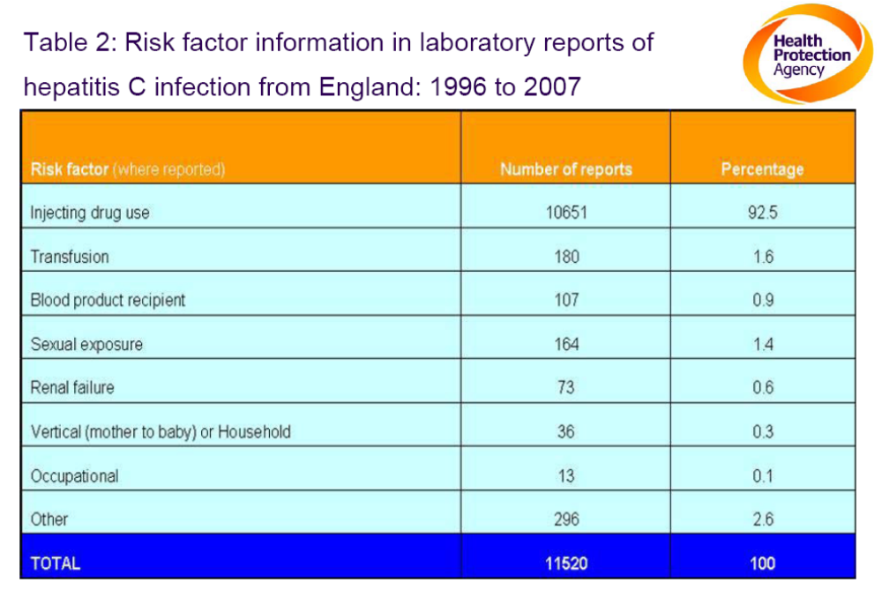

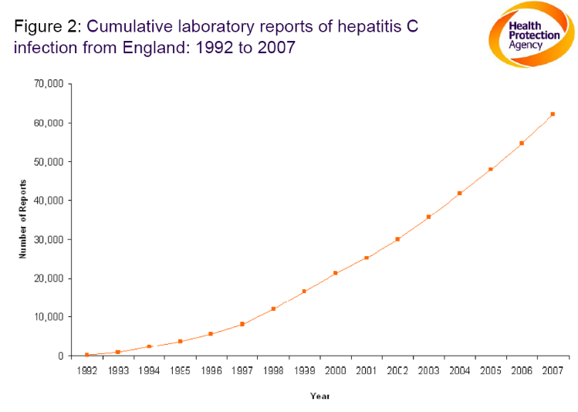
- Reporting HCV began in 1992 and by 2007, over 60,000 diagnoses of HCV infection had been made and notified with the majority of these likely to have been acquired through drug injection as suggested by the following graph.

- Although there has been an increase in the number of laboratory reports each year, the prevalence rate of HCV infection has not increased dramatically and remains fairly stable suggesting that the rise in cases is probably secondary to the increasing number of those being tested. Having said that, compared to the late 1990s when the prevalence was around one in ten, in 2007 it was said to be around one in five.
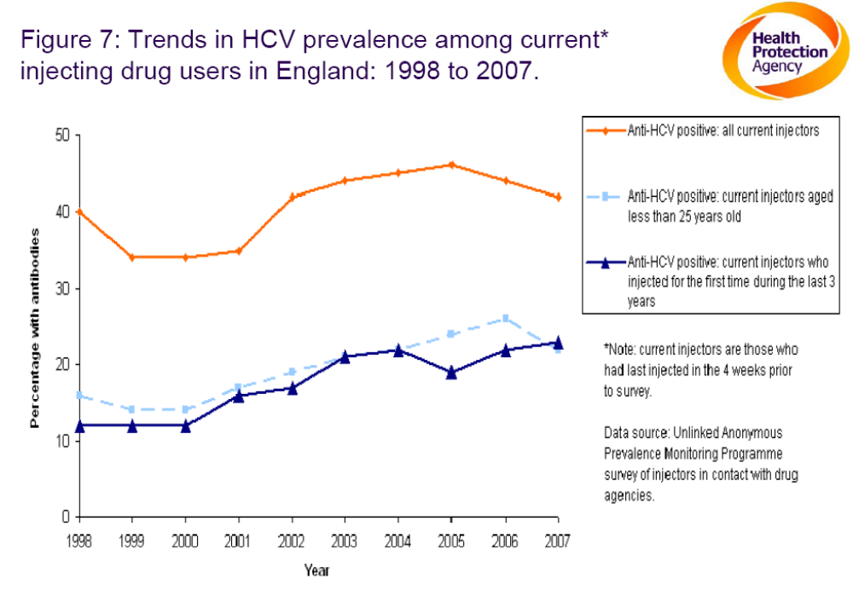

- Up to 80% of those infected with HCV develop chronic infection and can go on to develop liver cirrhosis and cancer. Unfortunately, as hepatitis rates increase, so do the number of individuals who die from related complications as seen below in figure 19 from a HPA report.

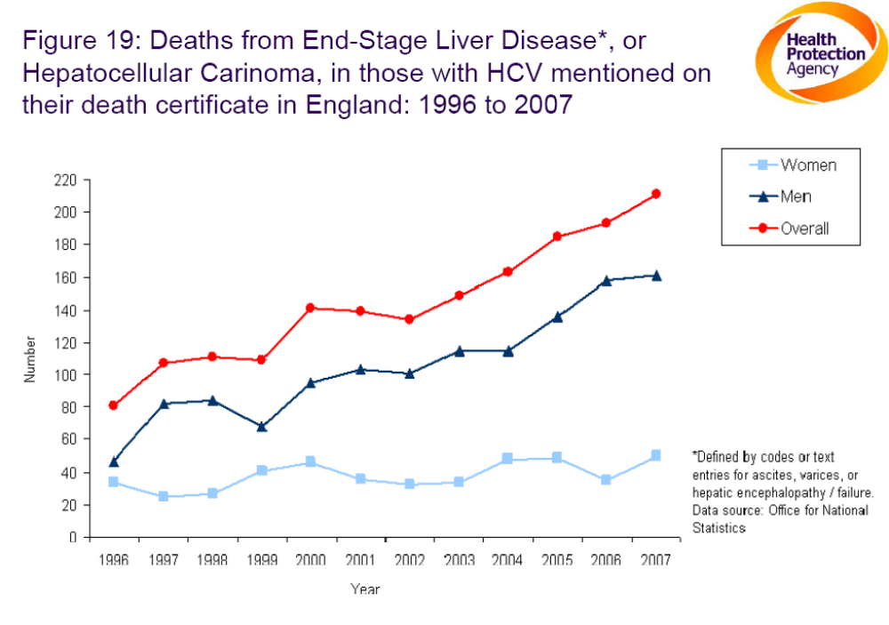
- Fortunately, there is an increasing proportion of IDU who are aware that they have an infection. Whether this awareness is reflected in their behaviour when taking drugs or having sexual relations is not clear. And even though awareness of infection is increasing, almost half of IDU with hepatitis C in contact with care in England and Wales are still unaware.

Hepatitis B
- The transmission of hepatitis B continues despite there being an effective vaccine. National data for hepatitis B level is not available for the last few years due to inadequate reporting. However it is believed that one in six IDU have had hepatitis B infection in the UK. There is some positive news with a marked increase in the number of injecting drug users receiving the hepatitis B vaccine, with two-thirds now reporting vaccination. Having said that, new infections are continuing to occur.

Hepatitis A
- Cases of hepatitis A continue to decrease with 352 reported cases of hepatitis A infection in 2007 in England and Wales.

Prisons
- Data from the HPA suggests that IDU form a significant proportion of the prison population at any one time and the vast majority of IDU are incarcerated at some time, and often on many occasions.

- In 2005, the North East Public Health Observatory found that certain groups with a higher than average burden of infectious disease (such as some ethnic minority populations, rough sleepers and those dependent on alcohol) are disproportionately more common in prisons compared to the community, resulting in higher prevalence of infections among prisoners including BBVs and HIV.

- In the prison population, hepatitis B and C are responsible for the most number of infectious disease cases in 2007-2008.

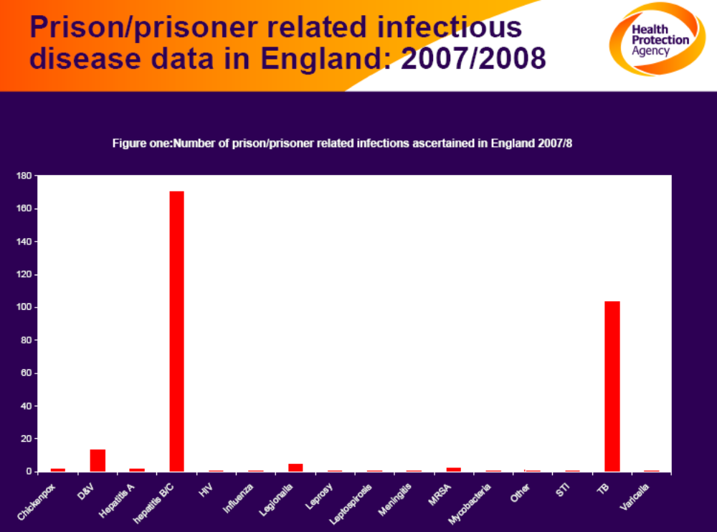

Hepatitis : Local
- Information about local hepatitis rates in East Sussex was collected from the Health Protection Unit. Data was available for the last 4 years.

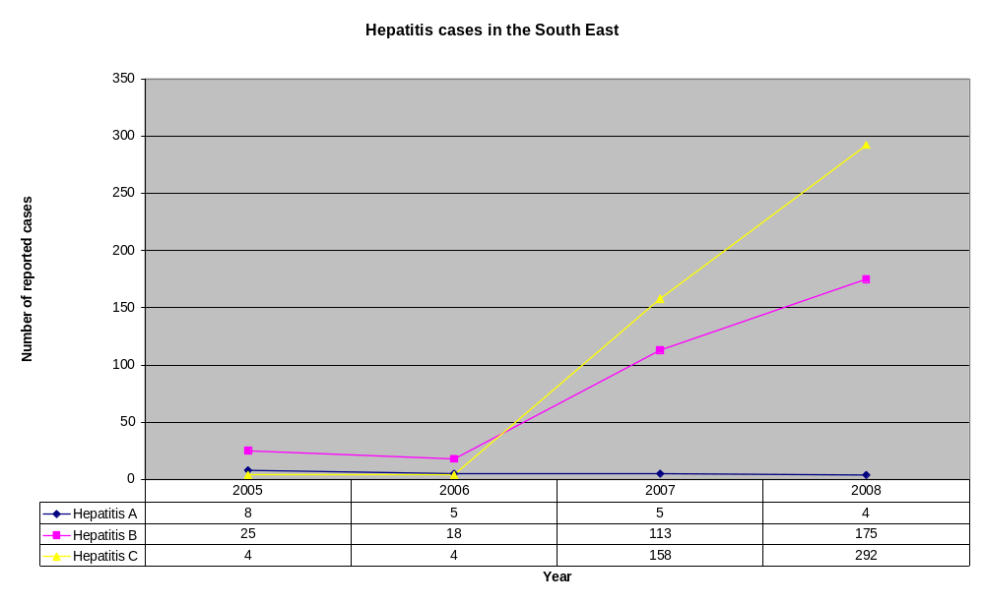
- The graph below shows a steady level of hepatitis A levels but a significant increase in the numbers of hepatitis B and C in the last two years.

- The most likely reason for this is better ascertainment of prevalence, due to more accurate reporting. Hepatitis is a notifiable disease and there has been considerable effort locally to improve recording to properly reflect local epidemiology.

- The local findings correlates with the national trend of hepatitis C which is showing an increase in the numbers infected.

- Data for the two PCT areas in East Sussex was compared. East Sussex Downs and Weald (ESDW) PCT has a higher rate of recorded hepatitis B and C infection in proportion to the population with an infection rate of 16 per 10,000, compared to 10 per 10,000 in Hastings and Rother (H&R) PCT.

- There may be a more reliable/effective notification system in place in ESDW or perhaps the public are more aware and therefore seek medical help in the first place leading to their diagnosis.

- Further analysis of the local data for hepatitis B and C in 2008 was carried out to see if there was any pattern in case distribution across East Sussex in terms of rural versus urban areas in the two PCT regions.

- The method in which this was done was by tracing the address of the GP surgery for the practitioner who was responsible for the individual with an infection. This was then put on a map of East Sussex. (Note: Not all the records had information about the GP.)

- It is clear there are limitations to this as GP surgery addresses do not necessarily correlate with the addresses of the affected individuals. The assumption was made that people would register to a nearby surgery. It is also accepted that the error in this may be greater in rural areas where the catchment area is bound to be larger. If there was any ambiguity in the data, this was excluded.

- The data cannot be mapped because the numbers are so low that in some areas there are fewer than 5 cases. We can say that there is a concentration of hepatitis cases in urban areas. This is to be expected – where there are more people there are likely to be more IDU and so more hepatitis B and C. This pattern of distribution is more marked in the Hastings and Rother area whereas with East Sussex Downs and Weald, the cases are slightly more evenly distributed. With Hastings & Rother, there were certain GP practices that had a high number of cases. Services targeting these practices or the surrounding area may be beneficial in supporting those affected.

- In East Sussex Downs and Weald, hepatitis B cases were reported particularly in Eastbourne, Crowborough, Uckfield and Lewes. Hepatitis C was reported particularly in Eastbourne and coastal Lewes District, although there were a number of single cases spread across the rural area.

- In Hastings and Rother, both hepatitis B and hepatitis C cases were reported particularly in Hastings and Bexhill, with only one case reported in rural Rother.

HIV : National
- According to the HPA, transmission of HIV infection through injecting drug use remains higher than in the late 1990s with around one in 100 of recent initiates having HIV. It is believed that overall about one in 90 injecting drug users have HIV. From data collected up to 2007, 5.2% of all HIV diagnoses reported in the UK were thought to have been acquired by drug injection (4,891 out of 94,897). Trends in the prevalence of HIV infection among IDU seem to be reasonably stable but there is evidence to suggest that HIV prevalence amongst recent initiates has increased recently especially in the areas outside London where previously levels were low. In recent years, around half of the cases are due to have been infections acquired from abroad.

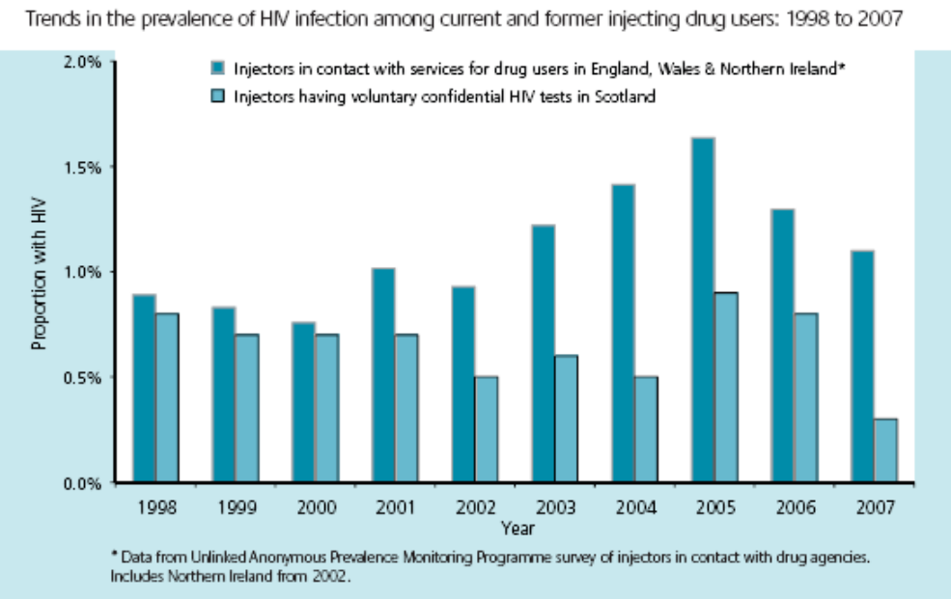

- The concern is that there are a significant number of people who are living in the UK with HIV but unaware that they are infected. In 2007, 32% of IDU who took part in a survey reported never having had a voluntary confidential HIV test. This is reflected in the graph below showing the estimated number of adults living with HIV both diagnosed and undiagnosed. Although IDU individuals account for a small number of cases compared to men who have sex with men (MSM), this group of high risk individuals cannot be ignored.

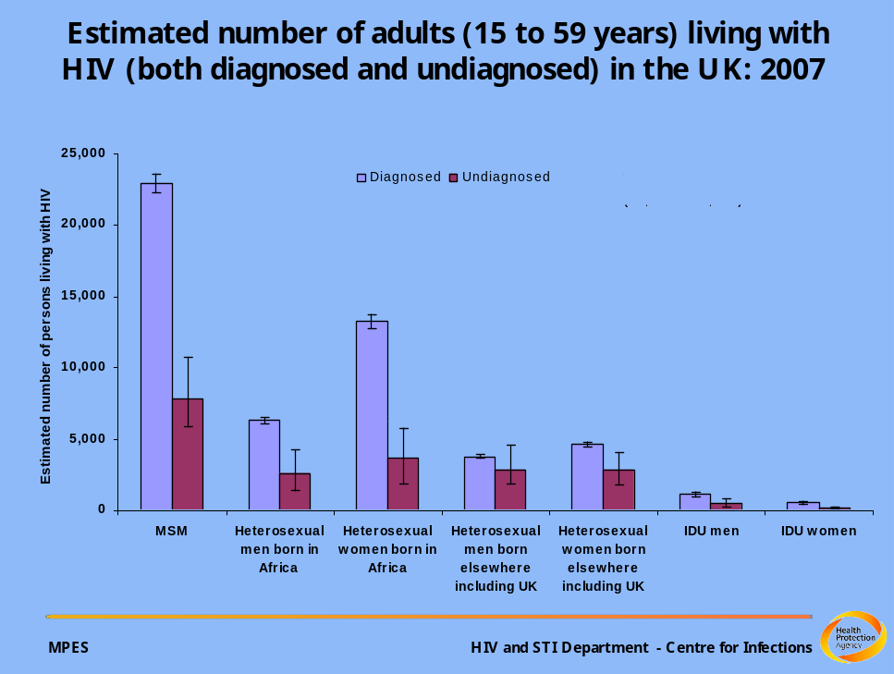

- The number of HIV infected IDU seen for care has increased by 22% from 2000 to 2007. However IDU accounted for only 2% of all HIV infected cases who were seen for care in 2007 and thus proportionally, fewer IDU infected with HIV are accessing care than those infected with HIV from the general population.

- The figure below shows that the majority of diagnosed persons nationally were seen for care around London but East Sussex also has a significant rate of people accessing services and this must be accounted for in commissioning plans.
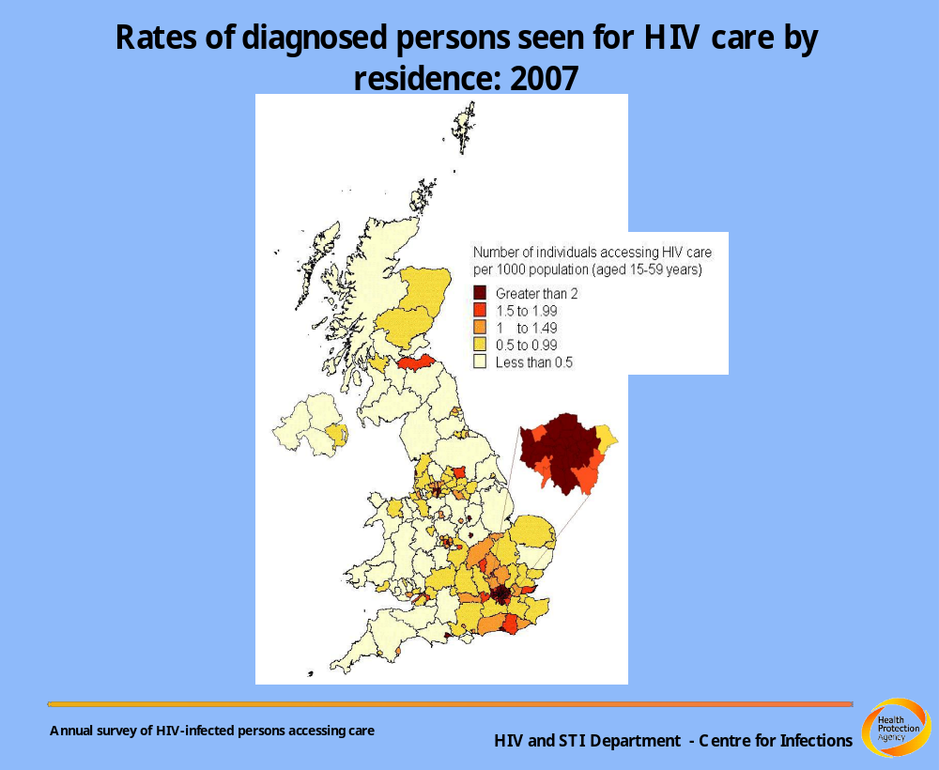

HIV : Local
- Collection of local HIV data has been a challenge especially due to confidentiality issues.
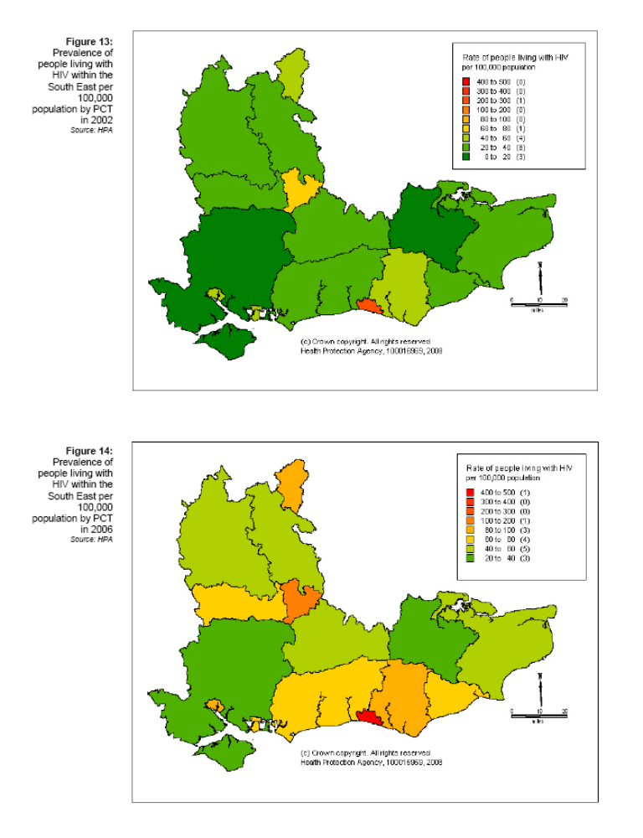
- There is some data available from the HPA:

- Figures available to the end of 2008 show that out of a total of 5523 cases of HIV in the UK, 216 individuals where HIV was probably acquired through injecting drug use were newly diagnosed with HIV in the South East Coast
- There were 56 HIV infected IDU who were seen for care in 2007 for the South East Coast region out of a total of 1466 for England and Wales.

Bacterial infections
Prevalence, incidence and treatment pathways – Dr Se-Yeon Park

Injection Site infections: National
- Most of the information about injection site infections discussed here comes from the HPA report “Shooting Up” last updated in 2008. Injection site infections are common, with around one-third of injecting drug users reporting having had an abscess, sore or open wound at an injecting site in the last year according to a report by the HPA last year. A recent increase in people taking crack cocaine and using the groin as an injection site has increased numbers of infections even more. It is believed that around a third of IDU are injecting crack-cocaine and groin injecting.

- Bacterial infections are thought to cost the NHS up to £47 million a year mainly secondary to hospital admissions. The most common causative organisms include Staphylococcus aureus, Group A streptococci, wound botulism and tetanus.

- Staphylococcus aureus infections can vary in severity ranging from minor skin infections to life threatening infection in the blood. Between April 2003 and December 2007 a total of 72 cases of injecting drug use related sepsis were identified in England and Wales.

- The UK has a higher proportion of group A streptococcal infections in injecting drug users than in many other European countries with one in five reports being in IDU. Increased surveillance data gathered between 2003-2004 identified drug injecting to be one of the most important risk factors for severe group A strep. infections in the UK.

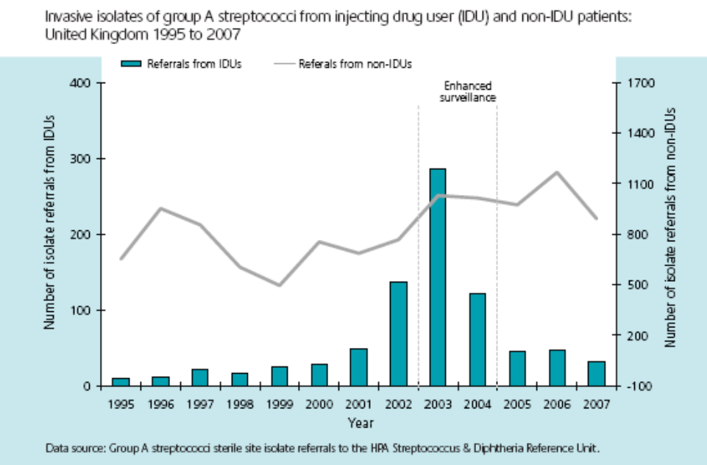

- With wound botulism in IDU, this is now the most common presentation of the infection seen in the UK with a total of 146 suspected cases in 2007, eleven of which were in IDU. There had been no cases reported among IDU before 2000. It is still an uncommon infection in the UK.

- The graph below shows the trend in tetanus cases in England and Wales with data from notifications, laboratory and clinical reports, and death certificates.

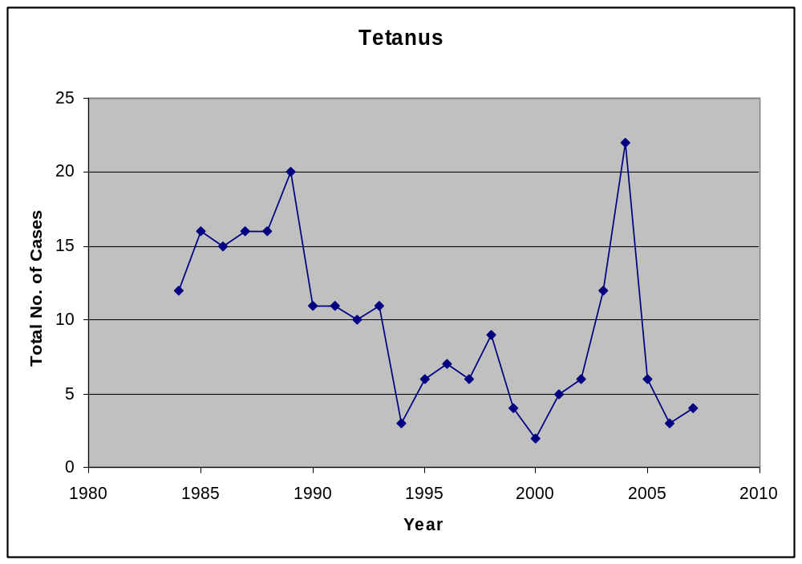

- Before 2003, tetanus was rare in IDU in the UK with only two cases being reported between 1984 and 2000 out of 175 which were reported. However in 2003 there was an outbreak with 25 cases being reported in just two years. Then from 2005 to 2007, seven of the fourteen cases of tetanus reported in the UK were in IDU.

Injection Site Infections: Local
- Local data on injection site infections is not readily available. One must rely on lab reports of swabs/samples, death certificates and notifications that have been sent usually from acute trusts but collating that data to see if it came from an injecting drug user comes with difficulties.

- Wound botulism associated with injecting drug use seems to be increasing in Southern England according to a recent Health Protection Report. Since January 2009, six cases of clinically diagnosed wound botulism have been reported. All the cases reported injecting heroin.

- One of the recommendations by the HPA in the Shooting Up report 2008 is for public health surveillance systems to be maintained and developed. For example, systems to improve the understanding of the extent of injecting site infections.

HPA Unlinked Anonymous Prevalence Monitoring Programme
- East Sussex is involved in the HPA Unlinked Anonymous Prevalence Monitoring Programme – the ‘Saliva Survey’, which detects the presence of salivary antibodies to HIV infection (anti-HIV), the core antigen of hepatitis B (anti-HBc) and Hepatitis C Virus (anti-HCV). Injecting drug users attending the specialist substance misuse service in Hastings are invited to anonymously provide a saliva test and answer a questionnaire. These are sent to the HPA. The HPA includes the results in national surveillance data and provides a report about findings, locally.

- Findings from the local survey of 144 IDU who participated in 2008 include:

- anti-HIV: less than 1%, similar to the previous year.
- anti-HBc: 19% HBc positive, similar to the national average.
- anti-HCV: 52%, similar to the previous year result (56%).

- The previous year, anti-HBc result was 12% - lower than anticipated. The test used has a sensitivity of around 75%. The anti-HCV test has a sensitivity of 93%.

- The survey found that 18% of people passed on or received used injecting equipment in the previous month (‘sharing’). In the 2007 survey, 27% of participants reported sharing. Nationally, sharing is reported by 25% of participants.

- 30% of participants reported a swelling in the previous year – an indication of an injection site infection.

- On the last day they injected, 31% of people injected once; 52% of people injected 2-4 times and 11% of people injected 5-9 times. This information was used to consider the ‘coverage’ estimate of two injections a day.

- 59% of people who reported having sex in the previous year reported ‘never’ using a condom. 23% reported ‘sometimes’ using a condom.

- 69% of people reported having previously been in prison, or a young offenders institution. 51% of these people had been in prison 5 or more times. 14% reported injecting drugs while in prison. Without access to NSP in prison, the risks of sharing and subsequent infection are clearly much higher.

- 75% of people reported having been homeless, half in the previous year.

Risks associated with co-morbidity

Drug misuse with alcohol misuse
- The 2009 NHS/ESCC Alcohol Joint Strategic Needs Assessment considered the needs of people experiencing problems with both drug and alcohol misuse. The National Treatment Outcome Research Study found that 33% of those entering residential treatment or community methadone programmes were drinking at levels above those recommended as safe.

- Alcohol is identified as a problem (included as a secondary or tertiary drug in NDTMS) for only 5 of the 423 current IDU in treatment. The scale of the problem is likely to be significantly higher, and the low figure is likely to be a recording issue. Although all patients at assessment are asked to complete an AUDIT form to screen for problematic drinking, historically they have not been asked whether alcohol was a secondary or tertiary problem drug. Only since the new assessment paperwork has been introduced (Feb 2010) has this information been gathered.

- Alcohol misuse represents a particular problem for drug misusers. It may increase the risk of relapse and overdose and is not tolerated by people who have hepatitis. Alcohol is a contributory factor in approximately half of local drug related deaths.

- The specialist substance misuse service is required to provide alcohol interventions to people with a drug misuse diagnosis who also misuse alcohol.

Drug misuse with mental health problems
- Drug misuse can make a mental health problem worse. People with mental health problems who use drugs have an increased risk of harm. Having both drug and mental health problems is often referred to as a ‘dual diagnosis’. Rethink (www.rethink.org/) has described some of the problems associated with dual diagnosis:

- making mental health symptoms worse
- provoking relapse and more frequent re-hospitalisation
- causing social and behavioural problems
- increasing the risk of suicide
- adding physical health risks such as HIV [and hepatitis C]
- poor eating habits
- liver damage
- complicating diagnosis and access to treatment.

- The DAAT 2009 needs assessment discusses dual diagnosis. The report suggests that between 4748 and 9890 adults would have both a mental health and a substance misuse problem.

- The DAAT 2009 needs assessment reports that of the 935 individuals who received drug treatment in 2008/9 where a ‘dual diagnosis’ status was recorded, 152 (16.3%) stated that they were receiving treatment from mental health services for reasons other than substance misuse. The report notes that anecdotally, staff have reported a much higher (than 16.3%) prevalence of previously undiagnosed mental ill health in the drug treatment population.

Workforce training needs analysis
- During 2008/9, service providers completed a harm reduction workforce training needs analysis. Staff completed a survey that considered how frequently particular interventions were delivered, and how recently staff had been trained. The findings are summarised below. Any comparisons relate to the results of the same survey completed in Brighton and Hove and West Sussex.

- Question A: Frequency of interventions delivered
- Of all the categories of interventions delivered, the interventions related to passing Dental Hygiene information to the clients scores the joint lowest (an average of 118).
- First Aid interventions is the category with the equal joint lowest score (average 118), however this may be artificially reduced given the low frequency of interventions around ‘Wound and Abscess Dressing’ that appear to be delivered (scores 102) and the relatively low number of items in this category (3).
- Health and Alcohol related interventions score the highest (average of 190).
- Whilst there is a great deal of consistency across the ‘sexually transmitted infections’ and ‘blood borne viruses’ (average 159) it is noticeable that information on the ‘tetanus vaccination’ and ‘common forms of infection’ are delivered far less frequently (scores of 82 and 111 respectively)
- Within the category ‘Access to services’ it is noticeable that the items ‘Provide details for on-line harm reduction resources’ (92) and ‘Access to harm reduction focussed organisations’ (100) score low in comparison to the other items within the category, and across all categories. Suggesting that the respondents may not be aware, or be identifying, these interventions as valuable aspects of ‘harm minimisation’ delivery.

- Question B: Recency of training received which included specific ‘harm minimisation’ interventions
- Of all the categories for recency of training the receipt of training including information on dental hygiene scores noticeably the lowest (average 83)
- The category ‘Injecting practice’ is relatively well balanced however the items ‘How to check injection sites for infection’ and ‘how to provide information on checking injection sites for infected clients’ score low (104 & 112 respectively). This suggests that these items may not be forming as regular a component of training which addresses injecting practice as the other items in the category.

- The report also notes that training around tetanus and ‘common forms of infection’ score low within the category looking at training on ‘sexually transmitted infections’ and ‘blood borne viruses’. It’s possible that the discussion about tetanus (a bacterial infection which is not sexually transmitted) within this category caused some confusion.

Tackling drug related litter
- DEFRA (2005) has published guidance about tackling drug related litter. The guidance relates specifically to contaminated sharps waste (needles and syringes). Locally, partnership working has been used to effectively address this issue when it has arisen.

03 ▪ CURRRENT SERVICES AND INTERVENTIONS
This section focuses on the services promoted through action taken by the DAAT across the four treatment tiers.

Treatment tiers
- The NTA (2006) describes different ‘tiers’ of intervention. These are defined as:

Tier 1: A range of interventions that can be provided by generic providers depending on their competence and partnership arrangements with specialised drug services.

Tier 2: A range of interventions that enable service users to engage in treatment without necessarily requiring a high level of commitment to more structured programmes or a complex or lengthy assessment process. Interventions include drug-related information and advice, screening, assessment, referral to structured drug treatment, brief psycho-social interventions and harm reduction services including needle exchange, and aftercare.

Tier 3: Structured, community based drug treatment interventions. Interventions include comprehensive drug treatment assessment, care planning and review, community care assessment, care co-ordination for those with complex needs, integrated harm reduction activities, prescribing, structured psychosocial interventions, structured day programmes and liaison services with social care and acute medical and health services.

Tier 4: Residential specialised drug treatment that is care planned and care co-ordinated. These interventions may be aimed at individuals with a high level of presenting need and usually will require a high level of motivation and commitment from the service user.

‘Tier 1’
Generic services including primary care and emergency services. Interventions provided locally include:

- All generic services
- NHS East Sussex Community Services – training for staff in tier 1 settings

- NHS East Sussex Community Services (health improvement) provide training about drugs and alcohol. The training comprises a number of discrete courses that are promoted locally, and workplace based training that provides basic drug awareness and promotes referral to local services.

‘Tier 2’
Specialist interventions including the needle and syringe programme delivered in specialist and community pharmacy settings. Interventions provided locally include:

- Community pharmacies providing needle and syringe programme
- Sussex Partnership NHSFT/CRI – Criminal Justice Integrated Team, Needle and Syringe Programme, advice and information
- ESCC Children’s Services – Safeguarding With Intensive family Treatment (SWIFT) – advice and information
- NHS East Sussex Community Services – Homeless health team, smoking cessation.

- Providers of open-access services (including needle exchange) have adopted a broad range of information campaigns, both in response to national campaigns and in response to locally identified need. These are coordinated across services to ensure key areas are routinely covered and to enhance impact for people accessing different services.

- The Criminal Justice Integrated Team (CJIT) targets drug misusing offenders and works to engage them with appropriate treatment.

- The Safeguarding With Intensive Family Treatment (SWIFT) service is integrated with Children’s Services, and provides targeted support to families in the child protection process. The service offers a ‘duty’ assessment and consulting function to other staff working in non-specialist Children’s Services roles without requiring a referral and full assessment.

- The Homeless Health team is a nurse-led service that works with homeless people in Eastbourne. In 2008/9 the service completed 1,426 client contacts, around half of which were with people who had drug or alcohol problems. The service provides advice and information, needle exchange and signposting to specialist services.

- The specialist substance misuse services are required to provide smoking cessation interventions opportunistically. All staff have access to training. The NHS stop smoking service also provides regular drop-in clinics on-site at specialist substance misuse services.

Needle and syringe programme (NSP)
- NICE (PH18) describes three ‘levels’ of NSP, recommending that services should be delivered by a balance of the types of service:

Level one: distribution of injecting equipment either loose or in packs, with written information on harm reduction (for example, on safer injecting or overdose prevention)

Level two: distribution of ‘pick and mix’ (bespoke) injecting equipment plus health promotion advice (including advice and information on how to reduce the harms caused by injecting drugs)

Level three: level two plus provision of, or referral to, specialist services (for example, vaccinations, drug treatment and secondary care)

- In East Sussex there are two specialist NSP based with other specialist drug services in Eastbourne, and Hastings. These are ‘level three’ services. All other NSP is provided through an ‘enhanced service’ arrangement with community pharmacies. These are ‘level one’ services, with equipment provided in pre-filled packs. These arrangements are coordinated by CRI in partnership with Sussex Partnership NHS Foundation Trust.

- The specialist services provide advice and information about harm reduction and drug treatment, clean injecting equipment, safe disposal for used equipment and access to a range of other specialist substance misuse services including hepatitis A and B immunisation, screening for hepatitis C and HIV, wound care and overdose management training.

- There are currently no mobile or outreach needle exchange services. A ‘peer distribution’ model has evolved with some NSP users taking additional equipment to pass on to people not in direct or regular contact with specialist services.

Equipment distributed
- NICE (2009) recommends that NSP should provide:

- Needles and syringes in a range of sizes. NICE recommends that NSP should encourage the use of identification schemes (for example coloured syringes) to reduce sharing in the event that single-use syringes are used multiple times.
- Sharps bins for safe disposal.
- ‘Other equipment’. The NICE guidance notes that at the time of publication, legally permitted equipment included filters, mixing containers and sterile water.

- Needles and syringes are provided in a range of sizes at specialist sites. These services also provide the ‘stericup’ single-use spoon, water, filter, swab, citric acid, ascorbic acid (vitamin C) and condoms

- Pre-filled packs are distributed through pharmacy NSP. For NHS Hastings and Rother, packs include 20x1ml combined needle and syringes, swab and citric acid. For NHS East Sussex Downs and Weald, two types of pack are available. Packs contain either 10x1ml combined needle and syringes, or 10x short orange needles with 10x2ml syringes – both packs include swabs and citric acid.

- Nationally, foil is an item distributed by some NSP. Foil is not explicitly excluded from the ‘paraphernalia’ restrictions within the Misuse of Drugs Act, making distribution of foil for the purposes of drug taking a criminal offence. Pizzey and Hunt (2008) found that distributing foil packs can be a useful means of engaging NSP attenders in discussions about ways of reducing injecting risks and can reduce injecting in settings where there is a pre-existing culture of heroin chasing. They also found that it can engage people who don’t inject who may not otherwise have engaged with any part of the treatment system. The Advisory Council on the Misuse of Drugs (ACMD) is to debate the issue in November 2009, following which there may be a review of the current legislation that deters distribution. Foil is not distributed through NSP in East Sussex.

Community Pharmacy NSP

- East Sussex PCTs have adopted the ‘harmonisation of accreditation group’ (HAG) accreditation process that was developed in the North West of England for pharmacists providing NSP. The programme has been adopted across the South East. In East Sussex, the framework is part of the enhanced service agreement with community pharmacy contractors. HAG provides a common framework for the training and competency requirements for all pharmacy staff involved in delivering the scheme. The HAG framework has recently been updated to incorporate NICE PH18 recommendations.

- At October 2009 NSP is available at 31 (31%) of community pharmacies. The NTA and Royal Pharmaceutical Society of Great Britain (2006) have described ‘best practice’ coverage (the proportion of pharmacies at which NSP is available) of at least 25%. For NHS East Sussex Downs and Weald, of 64 pharmacies, 19 (30%) provide NSP. For NHS Hastings and Rother, of 35 pharmacies, 12 (34%) provide NSP. Locations of pharmacies are indicated below (pharmacies expected to provide NSP by March 2010 are included in brackets):

Table 25: Current locations of pharmacy NSP
Locations of pharmacy NSP

Hastings | Rother | Eastbourne | Wealden | Lewes
Hollington  Ore  St Leonard’s (2) | Battle  Bexhill (4)  Robertsbridge  Rye  Sidley | Eastbourne (4)  Hampden Park  Langney  Willingdon | Crowborough  Hailsham  Heathfield  Herstmonceaux  Uckfield (2)  (Forest Row) | Lewes (2)  Telscombe Cliffs  Newhaven  Seaford  Peacehaven  (Ringmer)  (Newick)
4 pharmacies | 8 pharmacies | 7 pharmacies | 6 pharmacies | 6 pharmacies

- Services available during the evenings and at weekends are limited. Rother has the most accessible pharmacy NSP, with services available in the evenings and three pharmacies open on Sundays. The services available weekdays after 6PM and Sundays at any time are very limited – often being provided by the ‘100 hours’ pharmacies – pharmacies that offer 100 hours of service each week. There no evening service in Hastings, and only one service available after 9PM in Eastbourne, which ends at 11 PM. Saturday services are widely available in pharmacies, although these are sometimes limited to Saturday mornings only.

Table 26: Evening and weekend NSP availability
Number of specialist and pharmacy NSP available evenings and weekends

 | Specialist NSP | Pharmacy NSP | Weekdays  6PM-9PM | Weekdays  9PM–9AM | Saturday | Sunday
Hastings | 1 | 4 | - | - | 4 | -
Rother | 0 | 8 | 2 | 2 | 8 | 3
Eastbourne | 1 | 4 | 1 | 1 | 4 | 3
Wealden | 0 | 5 | - | - | 5 | -
Lewes | 0 | 2 | - | - | 1 | 1

- The volume of equipment distributed through pharmacies is expected to increase. In April 2009 the PCT promoted the Local Enhanced Service as a business development opportunity to pharmacists and contractors using a revised specification. High-street retail pharmacists are increasingly taking up this type of service alongside other enhanced services for testing, screening healthcare advice and so on as a matter of course.

- Needle exchange is also provided one evening each week at the Salvation Army centre in Eastbourne as part of a wider health service for people who access the services targeted at homeless people.

- Needle exchange following release from police custody was initiated in East Sussex during September 2006. An ‘exchange’ service has been made available to people leaving police custody who were in possession of injecting equipment when detained. This facility has not been used.

- Approximately 30% of people registered with the NSP are injecting steroids. The NSP hasn’t been promoted to steroid users, but there is clearly a demand for the service. The specialist NSP services are delivered from drug services that work primarily with opioid and crack cocaine users. Advice and information about steroid use is available in the specialist NSP, but this is an area of service that is not directly commissioned and is therefore not included in the service specification.

‘Tier 3’
Specialist interventions providing structured treatment in outpatient and community settings. Interventions provided locally include:

- Community pharmacies – supervised administration
- GP practices – shared care specialist prescribing
- Sussex Partnership NHSFT/CRI – specialist prescribing, structured psychosocial interventions
- ESCC Children’s Services – Safeguarding With Intensive Family Treatment (SWIFT) – specialist prescribing, structured psychosocial interventions
- NHS East Sussex Community Services – Integrated Drug Treatment System (IDTS) HMP Lewes – specialist prescribing
- CRI – Counselling, assessment, referral, advice and through-care (CARAT) – IDTS structured psychosocial interventions

Structured treatment
- For drug users, being in effective treatment is a highly protective factor. Service users who leave treatment have a significant risk of overdose. To be effective, treatment services need to keep service users engaged over a sustained period of time. Good planning and coordinated delivery of care is essential. The quality of local care planning processes has been the subject of a series of local quality audits, initiated in 2006. Audits have included a focus on risk assessment and risk management planning and communication of risk processes across the treatment system.

- Additional risk management training was provided for staff in specialist services during 2008/9. The impact of the training on the quality of risk assessment and risk management in care planning has not yet been assessed.

- Sussex Partnership NHS Foundation Trust has completed prescribing audits as part of its ongoing programme of clinical audit and improvement. One area of focus has been methadone dose. Clinical guidelines refer to a therapeutic methadone dose of 60-120mg daily. This is the dose at which the greatest benefit will be gained from methadone maintenance treatment. Routinely offering lower doses may lead to people leaving treatment early, or continuing to use other opioids as well as the prescribed medication. There will often be good clinical reasons for managing patients on lower doses. Audits have focused on identifying patients who are prescribed less than 60mg daily without a clear clinical reason. The most recent audit was completed in Eastbourne in 2008. 117 cases were randomly selected. Of these, 89 Patients were receiving opioid maintenance prescribing with a mean dose of 60.1 mg daily. 38 of these patients were receiving a dose of less than 60mg daily. Of the patients who were prescribed less than 60mg daily, 4 (10.5%) were without a clear clinical reason. This compares favourably to the previous (2007) audit, which found that in Eastbourne 17% and in Hastings 23% of patients who were prescribed less than 60mg daily were without a clear clinical reason.

- Service users in treatment for more than five years may require booster vaccination programmes. Services do not routinely offer a booster dose of hepatitis B vaccination injection to all patients five years after they have received their primary course of hepatitis B immunisation. Rather than just accept a booster jab, a number of patients choose to have a blood test to confirm their hepatitis B surface antibody titre (to determine their immune status), usually at the same time as having another BBV screen. If patients refuse to have a blood test, or if the blood test shows their antibody titre is sub-therapeutic, then a booster vaccination injection is offered.

- The proportion of service users who remain in treatment for at least three months or leave in a planned way before then has increased from 70% in September 2006 to 85% in December 2009. If a service user doesn’t attend the service when expected, they are assigned a named worker who will then actively seek to re-engage the person over the next three weeks.

- There are 36 pharmacies offering ‘supervised administration’ of medicines across East Sussex. Coverage is generally good, except that at weekends (and bank holidays) a dose for Sunday is often provided without supervision as the pharmacy is not available.

- During 2008/9, the ‘Integrated Drug Treatment System’ was introduced at HMP Lewes. The service has been fully operational since September 2009. At 1 December 2009 the service was providing psychosocial and medical drug treatment to 170 men at HMP Lewes, 140 of whom were receiving prescribed medication.

- Housing needs are considered by treatment providers as part of the ‘wrap around’ support offered to service users. Service users with a housing related support need are referred to the ‘Home works’ generic floating housing support service, funded by the East Sussex County Council ‘Supporting People’ programme.

‘Tier 4’
Specialist interventions providing structured treatment in inpatient and residential settings. Interventions provided locally include:

- Sussex Partnership NHSFT – inpatient stabilisation/detoxification
- A range of private and voluntary sector providers – inpatient detoxification and residential rehabilitation
- NHS East Sussex Community Services – Integrated Drug Treatment System (IDTS) HMP Lewes – inpatient stabilisation/detoxification

Inpatient detoxification
- Inpatient detoxification is provided by Sussex Partnership NHS Foundation Trust, or by a residential rehabilitation provider as the first stage of a treatment programme.

- All elective inpatient detoxification has been provided by Sussex Partnership at its specialist tier 4 substance misuse service (Promenade Ward).

- Contracts with residential rehabilitation providers have recently been revised to include a wide range of harm reduction interventions.

- Implementing the current health and social care commissioning strategy for adult drug misusers has increased the number of people accessing specialist treatment for drug misuse in the community. The strategy will be reviewed in 2010/11. Arrangements for inpatient detoxification will be considered further in the DAAT’s health and social care commissioning strategy for drug misuse.

Residential rehabilitation
- Residential rehabilitation services are purchased through ESCC Adult Social Care. ESCC contracts with residential rehabilitation providers for each service user individually. The contract includes a specification, which details the harm reduction interventions that must be provided for each person receiving the service. The specification was reviewed in 2008 to incorporate the range of interventions recommended by the Healthcare Commission (now Care Quality Commission) Improvement Review.

04 ▪ Gap analysis
This gap analysis draws on the information about need and current services in earlier sections, and the audits included in appendix one.

Workforce
- The training needs analysis suggests that front-line staff would benefit from training about infections associated with injecting drug use.

- Staff working in specialist alcohol services may not routinely benefit from training about harm reduction for drug misusers. This will reduce the potential for opportunistic harm reduction interventions for drug misusers in contact with alcohol services.

Think family
- In November 2009, the Department of Health (DH) and Department for Children, Schools and Families (DCSF) published joint ‘think family’ guidelines. The guidelines describe a series of actions recommended for drug partnerships and children’s services department. Once completed, the actions will reduce the risk of harm to children affected by parental drug misuse.

- The East Sussex Hospitals NHS Trust Special Care Baby Unit manages the treatment needs of babies who are born dependent on opiates. Formalising joint working arrangements with the SWIFT service would ensure that ongoing risks are managed appropriately within a multi-disciplinary framework following the child’s discharge from hospital.

Tier 1 interventions
- During 2009/10, substance misuse services and South East Coast NHS Ambulance Trust jointly developed a protocol to refer accidental illicit drug overdoses to specialist substance misuse treatment. The intention is for the specialist service to follow-up an ambulance attendance and encourage access to treatment to reduce the risk of further overdoses. The protocol is operational but has not yet resulted in any referrals to specialist services.

- Drug and alcohol misuse, poor nutrition and homelessness are all risk factors for tuberculosis, and yet there is very little focus on the identification and treatment of tuberculosis in the local PDU population.

Tier 2 interventions
- The CJIT receives referrals from CARAT – prison leavers who have been identified as having a drug treatment need on release. For the period June-August 2009, 46 people were referred by CARAT teams at various prisons to the local CJIT. 19 (41%) of these people were ‘picked up’ in the data recorded by the local CJIT. Prison leavers have a high overdose risk because of reduced tolerance.

- The reach of the information campaigns provided in specialist services is limited to those people in contact with specialist services.

Needle and Syringe Programmes
- Not enough injecting equipment is being distributed. Coverage is far below the 100% required by NICE guidelines and fewer than half of the estimated IDU are using local NSP services. This means injecting equipment is not getting to people who need it, is being re-used, and is likely to be shared. It is critical to ensure that needle exchange services are easily available.

- The directly provided NSP comprises ‘level one’ pharmacy based NSP and ‘level three’ specialist NSP. There are no ‘level two’ services, providing a ‘pick and mix’ approach and more specialist advice and information. The people who don’t use the specialist NSP in Hastings or Eastbourne will only access level one services, and will have less access to specialist advice.

- Pharmacy based NSP provides good access in many localities – and exceeds the ‘at least 25% of pharmacies’ best practice guideline - but is not available everywhere. In rural districts, public transport links can be limited. NSP should be available close to where people live, and in locations that have good transport links. Lewes District and Hastings stand out as being priority localities for better access to NSP. The following localities would be reasonable locations for further expansion of pharmacy NSP to improve access. Those expected to start by March 2010 are included in brackets:

Table 27: Areas where pharmacy NSP is an identified gap
Locations where access to pharmacy NSP has been identified as a gap

Hastings | Rother | Eastbourne | Wealden | Lewes
Central Hastings |  | (Willingdon) | Polegate | (Newick)  (Ringmer)

- There is no access to NSP in the evenings and Sundays in Hastings and Wealden, and limited Sunday availability in Lewes.

- The HAG provides the framework for auditable training records for community pharmacy NSP. Training is provided for community pharmacists, but there isn’t an auditable training record for counter staff. The latest update to the HAG framework has not yet been adopted locally.

- The contents of the packs distributed through pharmacy NSP in each locality are different. The reason is historical, rather than because of any difference in assessed need.

- The ‘never share’ syringe has been piloted, but isn’t in general use. No other identification scheme is being used.

- There are legal barriers that are preventing distribution of foil through needle and syringe programmes, despite evidence of effectiveness and local demand from service users and providers.

- Tetanus immunisation is not routinely offered to people who register with the needle exchange although it could be offered alongside other vaccination programmes.

- There is no NSP in accident and emergency settings – the NTA has included access to clean injecting equipment on discharge from emergency care, especially when other NSP services are closed, as good practice.

- The national information requirements for NSP are considerably lower than the requirements for structured treatment. The National Drug Treatment Monitoring System (NDTMS) reports about activity and outcomes from drug treatment do not include NSP. Although information about NSP users is collected locally, reporting within the DAAT partnership about the activity and impact of NSP is very limited.

- The services are generic, rather than targeted. The NSP can be accessed without providing lots of personal information, and the information about the profile of individual NSP users is therefore quite limited. The lack of data collected makes the service very accessible, but it also makes it quite difficult to assess whether there are any groups that are under-using the service. Without that information, there has been only a very limited attempt to develop any targeted services. The only targeted service focuses on accessing homeless people by providing a service at the Salvation Army citadel, with other services for homeless people.

- There are a significant proportion of NSP users who are injecting performance and image enhancing drugs (PIED, generally steroids) and accessing the NSP, but the commissioned service is not targeted at their needs.

Tier 3 interventions
- Procedures are not in place for sexual partners and household contacts to be supported and tested for hepatitis B, hepatitis C and HIV where appropriate. There is no programme to routinely vaccinate sexual partners or children for hepatitis A or B.

- Practice has not been audited across some important policy areas.

- Those who are at continuing risk of infection are offered a clinically appropriate hepatitis B vaccination intervention at around 5 years.
- Individual care plans include on-going assessment of risks of drug related harm from sudden overdose, BBV and other communicable diseases, bacterial endocarditis, skin botulism, septicaemia etc
- Including smoking cessation routinely in care plans
- Sexual health promotion, screening and materials available in all residential rehabilitation settings used by the partnership
- Emergency protocols and resuscitation equipment (possibly including naloxone) in clinical settings.
- Prescribing audit in Hastings and Rother

- Take-up of training for carers about managing overdose (including naloxone distribution) has been low.

- Liaison between A&E and drug services is not reflected in referrals to specialist drug treatment.

- Relying on bloods for hepatitis C testing may be preventing take-up of testing, identification of hepatitis C positive cases, and onward referral for treatment. It is possible to administer a ‘blood spot’ test for hepatitis C which is much less invasive. Adoption of this testing approach for specified groups may increase take-up of testing and treatment.

- Some service users have reported that they find it difficult to store medicines safely at home, increasing the risk of prescribed medication being diverted and used illicitly.

- Take-up of housing related support has historically been quite poor. New ‘housing clinics’ have been established in the substance misuse services, and the DAAT treatment plan for 2010/11 includes a commitment to review the impact of these by October 2010.

Tier 4 interventions
- Commissioners need to ensure the capacity of specialist inpatient services is sufficient to ensure inpatient stabilisation and detoxification can continue to be provided in appropriate settings by staff who have the additional training and skills necessary to provide the service.

- Whilst residential rehabilitation specifications are clear about the requirement to provide harm reduction interventions, there has been no audit to systematically evaluate the interventions being provided.

Tackling drug related litter
- There is no centralised source of information about contaminated sharps waste. This is a limiting factor in any assessment of the true picture of the extent, location or nature of the problem.

05 ▪ PLANNED ACTIONS TO REDUCE HARM
- These planned actions form the DAAT’s action plans to reduce the transmission of blood borne viruses and to reduce drug related deaths. Prioritised actions will be included in the DAAT’s annual treatment plans.

Summary of high-impact changes

Action | Outcome
DRUG RELATED DEATHS (INCLUDING CONFIDENTIAL INQUIRY 2009)
- Suitable resuscitation equipment should be available for clinical settings, possibly including naloxone and the staff competent to administer it. | Staff in clinical settings are able to resuscitate service users in an emergency.
TIER ONE INTERVENTIONS
- Develop the ability of mental health services to provide harm reduction interventions to people with substance misuse issues who are accessing mental health services. | harm reduction interventions are routinely provided to people accessing mental health services.
TIER TWO INTERVENTIONS
- The content of packs distributed through pharmacy NSP will be reviewed to ensure that what is given out in packs is the same across East Sussex and reflects user choice and assessed need. The review will include consideration of injecting equipment that can be identified to encourage the avoidance of sharing if single-use equipment is re-used. | Equipment distributed through pharmacies is the same throughout East Sussex and reflects what users need. The NICE guidelines about an identification scheme are implemented.
- NSP provision will be developed further to ensure it is easily accessible in the localities identified as ‘gaps’. | NSP is easily accessible throughout East Sussex, increasing coverage and reducing sharing.
TIER THREE INTERVENTIONS
- Introduce ‘blood spot’ testing for hepatitis C for [to be] specified groups | More IDU entering treatment will be screened for HCV.
TIER FOUR INTERVENTIONS
- The partnership will continue to ensure all inpatient services are provided in specialist settings. | Service users receiving an inpatient service do so in an environment that is appropriate to their needs.
HARM REDUCTION COMMUNICATIONS STRATEGY
- The reach of local information campaigns will be improved by providing harm reduction information in other appropriate settings. | People who aren’t in contact with specialist substance misuse services will benefit from information about harm reduction.

Other lower priority recommendations for action:

Drug Related Deaths (including Confidential Inquiry 2009)
- Data will be collected collection in relation to tier 2 treatment interventions (i.e. outreach, needle exchange and after care). The new ‘Nebula’ case management system will be used by treatment providers, and it will collate data about tier 2 interventions. Completion - July 2010.

Outcome: Information about tier 2 interventions can be used to identify unmet need and inform commissioning decisions.

Tier One Interventions
- Development of relationship between structured treatment services and discharge nurses for A&E to improve care pathway and deliver vaccinations to high risk individuals at the point of presentation to acute services. Completion - Year 1.

Outcome: Drug users who receive a service at a local acute hospital are encouraged to access drug treatment.

- Consider plans to introduce routine testing for blood borne viruses at GP registration and/or hospital admission. Completion - Year 3.

Outcome: More IDU are screened for Hepatitis C and HIV.

- Work closely with the Health Protection Unit to improve screening and referral pathways for tuberculosis. Completion - Year 2.

Outcome: More IDU are screened for TB and infection is treated earlier.

Tier Two Interventions
- Local implementation of the HAG accreditation framework will be reviewed to ensure staff are trained, training records are completed, a register of accredited practitioners is maintained and that the latest update to the HAG framework for NSP has been adopted. Completion – Year 1.

Outcome: NSP is provided by pharmacy staff who are competent to a common, accredited standard.

- The development of services for people using performance and image enhancing drugs who access the NSP will be planned and specified. Completion – Year 1.

Outcome: People using performance and image enhancing drugs as IDU will have access to appropriate services.

- An awareness campaign will distribute DVD videos, leaflets and other resources about blood borne viruses, bacterial infections and overdose. Completion - Year 1.

Outcome: Injecting drug users are informed about the risks of injecting drug use and practical harm reduction approaches.

- Commissioners will consider the development of ‘level two’ NSP services. Completion – Year 2.

Outcome: Commissioning plans for NSP will aim to develop a balance of level one, two and three services and ensure services are accessible across East Sussex.

- NSP provision will be developed further to ensure the service is available in the evenings and on Sundays. Completion – Year 2.

Outcome: NSP is easily accessible throughout East Sussex, increasing coverage and reducing sharing.

- Reporting about discarded needles should be coordinated. Reports gathered by environmental health services should be reported to the DAAT partnership. Completion – Year 1. The use of community disposal facilities will be considered with the involvement of the Health Protection Unit in any ‘problem’ areas identified – Year 2.

Outcome: The DAAT is aware of the environmental impact of NSP and is able to respond to any issues in a coordinated way.

- The potential for developing NSP in hospital pharmacies will be explored. Completion – Year 1.

Outcome: NSP is easily accessible throughout East Sussex, increasing coverage and reducing sharing.

- Tetanus immunisation will be routinely offered to people using NSP and injecting drug users entering drug treatment. Completion – Year 2.

Outcome: More injecting drug users are immunised against tetanus.

Tier Three Interventions
- Ensure that clinical governance arrangements around care planning continue to focus on improving harm reduction activities by addressing risk assessment and contingency planning. Completion – Year 1.

Outcome: Risk management processes continue to improve.

- Develop a formal protocol that describes joint working arrangements between the East Sussex Hospitals NHS Trust Special Care Baby Unit and the East Sussex SWIFT service. Completion – Year 1.

Outcome: The SCBU and SWIFT services work jointly to ensure families receive ongoing support and treatment appropriate to their needs.

- Complete a review of the ‘housing clinics’ in substance misuse services, to inform the development of housing related support as part of the DAAT’s annual treatment planning process.

Outcome: The development of housing related support services is based on local evidence of effectiveness.

- Findings from the NTA’s naloxone pilots will be used to inform local activities that increase carers’ involvement in overdose management training (including naloxone distribution). Completion – Year 2.

Outcome: More carers will feel confident about managing overdose.

- Providers’ clinical audit plans should include a harm reduction focus, including:
- Offering smoking cessation interventions;
- HBV vaccination booster doses for service users in treatment for more than five years with a continuing risk. Completion – Year 2.

Outcome: Clinical audit is used to improve harm reduction practice.

- Sexual partners and household contacts of service users accessing treatment should be supported and screened for blood borne viruses, and vaccinated against HAV and HBV using the combined ‘Twinrix’ vaccination as appropriate. Completion – Year 3.

Outcome: People in ‘at risk’ populations are screened for blood borne viruses, and protected by vaccination when appropriate.

Tier Four Interventions
- There will be an evaluation of the harm reduction interventions delivered by the residential rehabilitation services that are used by the partnership, with recommendations for improvement as appropriate. Completion – Year 2.

Outcome: The partnership ensures that service users are placed with residential rehabilitation providers who deliver the full range of harm reduction interventions specified in contracts.

Strategic Management
- The strategy will be communicated by adopting specific messages and media for particular groups.

- The DAAT Harm Reduction Group will be accountable for the delivery of the objectives described by this harm reduction strategy. The Group will continue to review drug related deaths through the annual Confidential Inquiry process, and will address any additional improvements recommended by that process as they emerge.

- Reporting will be developed to ensure information about the activity and impact of harm reduction interventions, including NSP, is easily accessible.

- The objectives described by this harm reduction strategy will be included in the DAAT’s annual treatment plans. Progress will be monitored by the Harm Reduction group, reported to the DAAT Joint Commissioning Group (JCG) and DAAT Board by exception.

- The DAAT will publish the strategy on its website. DAAT partnership organisations will include key messages and objectives relevant to their area of work within their own strategic frameworks.

Bibliography

DEFRA (2005) Tackling Drug Related Litter: Guidance and good practise. London: DEFRA. http://www.defra.gov.uk
East Sussex DAAT (2009) Adult Drug Treatment Needs Assessment. Eastbourne: East Sussex County Council.
http://www.safeineastsussex.org.uk/
Hay, G., Gannon, M., MacDougall, J., Millar, T., Eastwood, C., Williams, K., and McKeganey, N. (2008) Estimates of the prevalence of opiate use and/or crack cocaine use (2006/07) South East Region. London: Home Office.

http://www.nta.nhs.uk/areas/facts_and_figures/prevalence_data/docs/0607/
South_East_Prevalence_data_0607doc.pdf
Health Protection Agency (2008) Shooting Up: Infections among injecting drug users in the United Kingdom 2007 – An update, October 2008. London: HPA.
http://www.hpa.org.uk/
Health Protection Agency (2009) Shooting Up: Infections among injecting drug users in the United Kingdom 2008 – An update, October 2009. London: HPA.
http://www.hpa.org.uk/
National Institute for Health and Clinical Excellence (2009) Needle and syringe programmes: providing people who inject drugs with injecting equipment (Public Health Guidance PH18). London: NICE. http://www.nice.org.uk/ph18
National Treatment Agency and Royal Pharmaceutical Society of Great Britain (2006) Best practice guidance for commissioners and providers of pharmaceutical services to drug users. London: NTA http://www.nta.nhs.uk
National Treatment Agency for Substance Misuse (2005) Harm reduction self-audit tool. London: NTA. http://www.nta.nhs.uk
National Treatment Agency for Substance Misuse (2006) Needs Assessment Manual. London: NTA. http://www.nta.nhs.uk
Newcombe, R. (1992) The reduction of drug related harm: a conceptual framework for theory, practice and research. In, O’Hare et al (Eds.) The reduction of drug related harm. London: Routledge.
North East Public Health Observatory (2005) The Health Needs of Prisoners. Occasional Paper No.16, Nov 2005. http://www.nepho.org.uk
Park, S (2009) Harm Reduction. This unpublished needs assessment was produced by Dr Se-Yeon Park during his term as Public Health SHO with East Sussex Primary Care Trusts.
Pizzey, R. and Hunt, N. (2008) Distributing foil from needle and syringe programmes (NSP) to promote transitions from heroin injecting to chasing: An evaluation. Harm Reduction Journal 2008, 5:24 http://www.harmreductionjournal.com/content/5/1/24
Skills for Health (2003) Drug and Alcohol National Occupational Standards. http://www.fdap.org.uk/DANOS/danos.html
World Health Organization (2007) Guide to starting and managing needle and syringe programmes. Geneva: World Health Organization

Appendix One – Audit results

1. Harm reduction self-audit
The following issues were identified as ‘amber’ or ‘red’ by the DAAT’s audit in August 2009. The majority of the audit self- assessment was ‘green. All ‘green’ assessments have been left out of this report. The full audit framework is available for download at www.nta.nhs.uk.

2. Blood-borne Virus infections |  | Issues , comments , actions
Procedures are in place for sexual partners and household contacts to be supported and tested where appropriate | R | This does not happen routinely.
Sexual partners and children of injecting drug users should also be vaccinated, as should sexual partners and close household contacts of patients with chronic acute hepatitis B infection. | R | There is no programme to routinely vaccinate sexual partners or children of these patients.
Policies are in place to ensure that those who are at continuing risk of infection are offered a booster dose at around 5 years. | A | Practice has not been audited.
Processes and pathways are in place for injecting drug users to access screening and treatment for tuberculosis and screening and immunisation for tetanus. | A | Care pathway though primary care. On-site tetanus immunisation to be considered as part of harm reduction strategy refresh. [TP 6.1]
4. Drug Related Deaths |  | Issues / comments / actions
Liaison between A&E and drug services, referral systems, care pathways, injecting equipment | R | There is liaison, but referral rates are very low. Injecting equipment is not available in A&E settings. Action should be included to address this in part 3 of the treatment plan and in the harm reduction strategy refresh.
Prevention and management of overdose in custody | A | Custody staff are trained as part of the general management of healthcare emergencies.
All services have an emergency protocol that covers the management of drug overdose (including rapid ambulance call, competent preservation of clear airway and possibly emergency administration of Naloxone) | A | Emergency administration of naloxone is not routinely available.
Suitable resuscitation equipment should be available for clinical settings, possibly including Naloxone, and the staff competent to administer it. | R | Action should be included to address this in part 3 of the treatment plan and in the harm reduction strategy refresh.
A range of overdose measures is provided to carers of opiate misusers, which might include information, advice and training on avoiding overdose, recognising the signs of overdose and first aid, and might include the use of Naloxone. | A | There is a training programme for carers which includes these areas. Only a small proportion of carers currently benefit from the training. Take up of training about naloxone administration has so far been very low.
6. General Health Care |  | Issues / comments / actions
Individual care plans provide on-going assessment of general / primary healthcare needs, including risks of drug related harm from sudden overdose, BBV and other communicable diseases, bacterial endocarditis, skin botulism, septicaemia etc | A | The 2008 care plan review identified continuing deficits in care planning for a significant proportion of cases across a number of domains. Work is in hand to achieve the required standard. Delivery will be monitored through the 2009/10 treatment plan with a follow-up audit to review achievement. [TP 3.3]
Smoking cessation treatment opportunities are routinely offered to clients in drug treatment, as with the wider population | A | This hasn’t been audited, and could be included as part of the regular review of care plans.
Sexual health promotion, screening and materials available in all residential rehabilitation settings used by the partnership | A | This forms part of the service specification, but practice has not been audited.

2. NICE PH18 Needle and Syringe Programmes
The following issues were identified as ‘amber’ or ‘red’ by the DAAT’s audit in August 2009. All ‘green’ assessments have been left out of this report. The full audit framework is available at www.nice.orh.uk/ph18/

Recommendation 1: Planning, needs assessment and community engagement |  | Issues , comments , actions
1.2 The data should be used to ensure NSP services meet local need (for example in terms of opening times and locations), taking the geography of the location into account (for example, whether it is in an urban or rural area) | A | A review of NSP availability is included in this harm reduction strategy. Areas of further expansion are to be identified.
Recommendation 2: Meeting need |  | Issues , comments , actions
2.1 Commission a mix of generic and targeted NSP services to meet local need. | A | The services are generic, rather than targeted.
2.2 Targeted services should focus on specific groups identified in 1.1  High risks groups may include:  - homeless people  - anabolic steroid users  - young people and people who have recently started injecting  - crack and speedball users  - prisoners  - women who inject drugs | A | A limited dataset is recorded about NSP users, making it difficult to assess the profile of current service users.  There is a significant usage of the service by anabolic steroid users.  There are no services targeted at prisoners whilst in custody.
2.3 Services should aim to increase the proportion of individuals who have over 100% ‘coverage’. | A | Coverage – using the NICE PH18 definition – has been calculated as 33%  Coverage is being increased by increasing the number of pharmacies involved in the NSP
2.4 Services should aim to increase the proportion of people from each group (see 1.1.2.2) of injecting drug users who are in contact with NSP | A
2.5 Services should aim to ensure syringes and needles are available in a range of sizes and at a range of locations throughout the area | A | Syringes and needles are available in a range of sizes at specialist NSP sites.  Pharmacy services offer pre-filled packs that contain 1ml all-in-one syringes.  Foil has been discussed as a potential distribution item, but currently not exempted from Misuse of Drugs Act Section 9a.
2.7 Develop plans for needle and syringe disposal, in line with ‘Tackling drug-related litter’ (Department for Environment, Food and Rural Affairs 2005) | A | Where issues have arisen, joint planning and partnership working have been effective.  The reporting of sharps finds isn’t coordinated.
2.8 Encourage identification schemes (involving, for example, the use of coloured syringes) | A | The ‘never share’ syringe has been piloted but isn’t in general use.
Recommendation 3: Types of service |  | Issues , comments , actions
3.1 Use pharmacies, specialist NSP and other healthcare settings to provide a balanced mix of the following levels of service:  Level one: distribution of injecting equipment either loose or in packs, with written information on harm reduction (for example, on safer injecting or overdose prevention)  Level two: distribution of ‘pick and mix’ (bespoke) injecting equipment plus health promotion advice (including advice and information on how to reduce the harms caused by injecting drugs)  Level three: level two plus provision of, or referral to, specialist services (for example, vaccinations, drug treatment and secondary care) | A
3.2 Coordinate services to ensure injecting equipment is available throughout the LSP area for a significant period of time during any 24-hour period. | A | Access to services in evenings and at weekends is restricted to urban centres, using pharmacies with ‘100 hour’ contracts.
Recommendation 4: Equipment and advice |  | Issues , comments , actions
4.5 Encourage people who inject drugs to mark their syringes and other injecting equipment or to use easily identifiable equipment to prevent accidental needle and equipment sharing | A | The ‘never share’ syringe has been piloted but isn’t in general use.
Recommendation 4: Community pharmacy NSP |  | Issues , comments , actions
5.3 Ensure staff who dispense needles and syringes receive appropriate training for the level of service they offer. As a minimum, this should include awareness training on the need for discretion and the need to respect the privacy of people who inject drugs. It should also include training on how to treat them in a non-stigmatising way, in particular, advice on how to reduce the harm caused by injecting | A | The PCT is introducing the Harmonisation of Accreditation Group (HAG) guidelines.  Training is provided for community pharmacists, but there isn’t an auditable training record for counter staff.
5.4 Ensure staff providing level two or three services (see recommendation 3) are trained to provide health promotion advice, in particular, advice on how to reduce the harm caused by injecting | A | The PCT is introducing the Harmonisation of Accreditation Group (HAG) guidelines.  Training is provided for community pharmacists, but there isn’t an auditable training record for counter staff.

Appendix Two – Additional actions being completed

The following actions were recommended in earlier drafts of the strategy. The actions were completed (or significant progress had been made towards completion) before the strategy was published, and these actions no longer need to be included in the DAAT’s action plans.

DRUG RELATED DEATHS (INCLUDING CONFIDENTIAL INQUIRY 2009)
Introduce a ‘lessons learned’ approach following any death of a service user in treatment.
Treatment providers will provide an appropriate summary following any death in treatment to include information about any lessons that might be learned and shared with other treatment providers.
A brief gap analysis about ‘dual diagnosis’ to be explored within the drug treatment needs assessment and progressed further into a wider project.
Introduce a system of early notification by Police particularly where children are likely to have been involved in each death. An alert system will be introduced that will identify these cases for all case management systems to be cross checked and Children’s Services advised where appropriate.
WORKFORCE
Ensure continuing professional development for front-line staff includes injection site infections.
THINK FAMILY
Develop a local ‘think family’ protocol between drug and alcohol treatment services and local safeguarding and family services, based on the 2009 DH/DCSF guidance.
TIER ONE INTERVENTIONS
Review the implementation and impact of the accidental overdose referral and follow-up protocol between SEC NHS Ambulance Trust and substance misuse services.
TIER TWO INTERVENTIONS
More information will be gathered about people using the NSP, so that there can be a proper assessment of the need for targeted services. The 2010 treatment planning needs assessment will consider whether the NSP effectively reaches the following groups:

- homeless people
- young people and people who have recently started injecting
- crack and speedball users
-women who inject drugs
- prisoners on release

And if not, will recommend that further actions are planned to increase the proportion of people from each group that access the service.

The introduction of a contingency management scheme to increase take-up of hepatitis B vaccination will be considered for NSP users not in treatment, following guidance anticipated from the NTA: This action was considered unnecessary as take-up is already good.
Routinely analyse information about CARAT referrals that are not picked up by the CJIT and identify opportunities to improve effective engagement.

