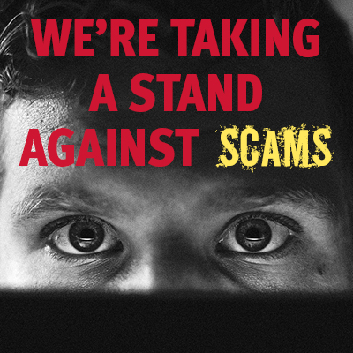

**It’s Scams Awareness Month -   
[the Safer East Sussex Team,   
East Sussex County Council]   
is raising awareness about scams to help protect people in East Sussex**

***Scams are fraud, and fraud is a crime –   
we shouldn’t ignore them!***